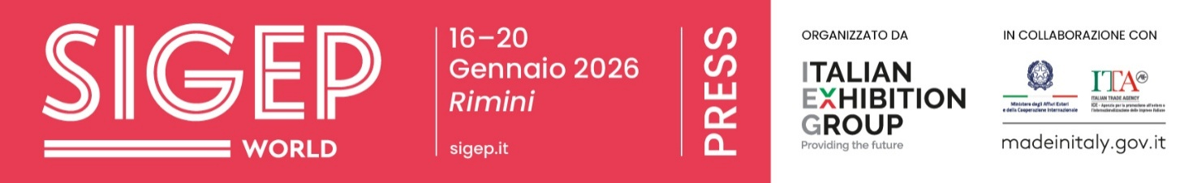

Closing press release
SIGEP WORLD, THE GLOBAL HUB FOR FOODSERVICE EXCELLENCE: OPERATORS FROM 160 COUNTRIES FLOCK TO RIMINI
- +33% growth in exhibitors from 45 countries, showcasing the excellence of Italian foodservice supply chains.
- Sigep reconfirmed the world’s most comprehensive and qualified showcase of Italian gelato.
- Almost one in four visitors are from abroad, with Spain, Germany, Romania, France, Greece and Poland leading the way.
- 500 top buyers from 75 countries and 5,650 business meetings facilitated through the Top Buyer Program. ​India Guest Country 2026: 50 leading buyers and specialised operators.

Rimini, 20 January 2026 —Just over a month after Italian cuisine was recognised as a UNESCO Intangible Cultural Heritage, SIGEP World has become a key meeting point for the international foodservice industry, bringing together markets, consumption patterns and business visions. ​The event, curated by Italian Exhibition Group at Rimini Expo Centre, ran from 16 to 20 January, reaffirming its position as a global platform for the gelato, pastry, chocolate, coffee, bakery, and pizza industries. This was particularly significant, given the value of the out-of-home sector, which is worth €71 billion in Italy alone (source: Circana). ​The presence of the Minister of Agriculture, Food Sovereignty and Forests, Francesco Lollobrigida – preceded by the Minister for Disabilities, Alessandra Locatelli – and the President of the Italian Trade Agency, Matteo Zoppas, highlighted the strategic importance of the industry and the development of human capital for its competitiveness.
GLOBAL FIGURES: INTERNATIONAL SUPPLY AND DEMAND FROM 160 COUNTRIES
The 2026 edition saw a significant increase in international participation, with a 33% rise in foreign exhibitors from 45 countries, alongside a strong and high-quality Italian presence. ​New entries include Canada, Saudi Arabia, Algeria, Ecuador, Estonia, Serbia, Singapore, Nepal, and the Czech Republic. ​This global initiative received a strong response, confirming the success of the previous edition: operators from 160 countries, with almost one in four visitors coming from abroad. ​The top six foreign countries: Spain (8.9%), Germany (6.6%), Romania (4.9%), France (4.1%), Greece (4.0%), and Poland (3.8%). The fastest-growing countries by continent: the United States (+2%), Argentina (+40%), the Philippines (+78%), and Serbia (+29%). Many African countries are attending the fair for the first time, including the Democratic Republic of Congo, Tanzania, Zimbabwe, and Guinea. ​All chose Rimini as a key location to discover emerging trends, technologies, and formats. ​The Top Buyer Program, a strategic collaboration between the Italian Trade Agency and the Ministry of Foreign Affairs, played a crucial role in bringing 500 buyers from 75 countries to Rimini, with notable representation from the United States, India, Canada, China, Brazil, Turkey, the United Arab Emirates, and Singapore. ​The encounter between supply and demand resulted in 5,650 business meetings, confirming SIGEP World as a working platform for international business development.
India was the Guest Country for 2026, with a delegation of 50 top buyers, institutional representatives, and exhibitors specialising in ice cream technology, confirming the dynamism of the Indian market in the foodservice and hospitality sectors. ​The 2026 edition also saw a significant increase in foreign press coverage, with a total of 802 accredited journalists, including many international correspondents from dozens of countries.

ENGAGING WITH INTERNATIONAL MARKETS
Interaction with top drawer global players was also particularly important and evident through the presence of National Pavilions and collectives from Saudi Arabia (debuting after the Guest Country 2025 project), China, and Ukraine. An ecosystem in which ingredients, technologies, and formats converged across geographical boundaries, reflecting an increasingly interconnected and hybrid foodservice landscape.
GELATO: A STRATEGIC LEVER FOR GLOBAL FOODSERVICE
A cornerstone of SIGEP World’s identity, artisan gelato remains not only a symbol of Italian excellence in 2026, but also a strategic asset for the global foodservice industry, capable of generating profit, differentiation, and new opportunities across various markets and formats. ​With Gelato Meets Chains, the event developed a project aimed at international restaurant, hotel, coffee shop and bakery chains, encouraging the inclusion of gelato in global menus. ​To reinforce this vision, the international campaign “What is Gelato?” and the guide “Gelato means Business” provided data, models, and concrete examples to demonstrate how gelato can generate high margins, seasonally adjusted consumption, and a rapid return on investment.
LUXURY FOOD EXPERIENCE: FOOD AS A NEW LANGUAGE OF HOSPITALITY
The Luxury Hotel Food Experience project also received significant attention, fostering a closer relationship between the hotel and foodservice industries. It found one of its fullest expressions at SIGEP World, showcasing breakfast as a true measure of contemporary hospitality. ​At Pastry Arena, breakfast was presented as a complete experience - a ritual that can become an economic lever and a means of differentiation for international hotels and formats.
SUSTAINABILITY DISTRICT: SUPPLY CHAINS, ORIGINS, INNOVATION
Sustainability has become a key focus of supply chain strategies, highlighted by the Sustainability District, which sparked an international dialogue on cocoa, coffee, and the new frontiers of sustainable food. ​The area connected producers, cooperatives, institutions, and companies across the entire value chain, bringing the voices of the countries of origin to the event, alongside technological solutions, energy innovations, and new models of cooperation. ​From Africa (Uganda, Rwanda, Ethiopia, Côte d'Ivoire, Tanzania and Kenya) to Latin America (Costa Rica, Guatemala, Dominican Republic), the district showcased supply chains increasingly focused on transparency, market orientation and responsibility.
CROSS-CUTTING PROJECTS: SUPPLY CHAINS MORE CONNECTED THAN EVER
SIGEP World also highlighted that the foodservice industry is no longer operating in isolated sectors, but through increasingly interconnected supply chains. ​Cross-cutting projects like the Kitchen Equipment Hub, the Frozen Product Hub, and the Digital District demonstrated how equipment, frozen solutions, and digital technologies are now essential factors in format design, operational management, and international business growth.

NEXT-GEN SIGEP: TRAINING IN NUMBERS
A key focus was also on the next generation of professionals, through SIGEP Giovani, SIGEP Academy’s training and competition programme for schools and vocational institutes. ​The initiative involved 53 Italian institutes and universities from 14 regions, with a total of over 2,750 participants. The international presence grew, with delegations from Serbia (5 vocational training institutes from Belgrade and over 360 participants) and Slovenia (115 participants from three-year university courses and vocational training institutes). ​The SIGEP Academy programme also hosted 10 fully sold-out events dedicated to schools, with 270 participants.
INTERNATIONAL CHAMPIONSHIPS: A PROVEN SUCCESS
Completing the picture, the success of major international championships – from the Gelato World Cup (won by Singapore, followed by France and Argentina) to the Juniores Pastry World Cup – has reinforced SIGEP World as a global showcase for talent and expertise, further strengthening the connection between training, excellence, and the industry’s future.
SIGEP WORLD: KEY FOODSERVICE MARKETS
Finally, the show’s global profile is further strengthened by an international development strategy that extends far beyond Rimini. ​Upcoming events include SIGEP USA, scheduled for 24-26 March 2026 in Las Vegas, the SIGEP China roadshow in Shanghai in spring 2026, and SIGEP Asia, taking place 15-17 July 2026 in Singapore, all aimed at addressing some of the most dynamic areas of the global foodservice industry.
IMPROVED AIR CONNECTIONS AND OPTIMISED CITY MOBILITY
The event’s growing international reach was boosted by improved connections and access services for buyers and exhibitors. ​New direct flights to Rimini from Munich and Madrid were launched, alongside a partnership with the Lufthansa Group that offers discounted fares to Bologna Airport from over 310 destinations worldwide.
Regarding road traffic, the expo centre’s opening hours from 10 am to 6 pm, the reorganisation of the road network, and the optimisation of public transport services – thanks to close collaboration with the Municipality of Rimini – all contributed to smoother traffic flow, significantly improving road conditions and reducing peak-hour congestion.
Italian Exhibition Group looks forward to hosting the next edition of SIGEP World at Rimini Expo Centre in January 2027.

ITALIAN EXHIBITION GROUP PRESS CONTACTS| media@iegexpo.it
head of corporate communication & media relation: Elisabetta Vitali|
press office manager: Marco Forcellini, Pier Francesco Bellini | international press office coordinator: Silvia Giorgi | press office coordinator: Luca Paganin | press office specialist: Nicoletta Evangelisti, Mirko Malgieri
MEDIA AGENCY SIGEP World: Mind The Pop
Martina Vacca: martina@mindthepop.it, mob. +39 339 748 5994; Fabrizio Raimondi: fabrizio@mindthepop.it, mob. +39 335 389 848; Benedetto Colli: benedetto@mindthepop.it, mob. 380 371 2272; Stefano Chiossi: stefano@mindthepop.it, mob. + 39 388 739 4358.

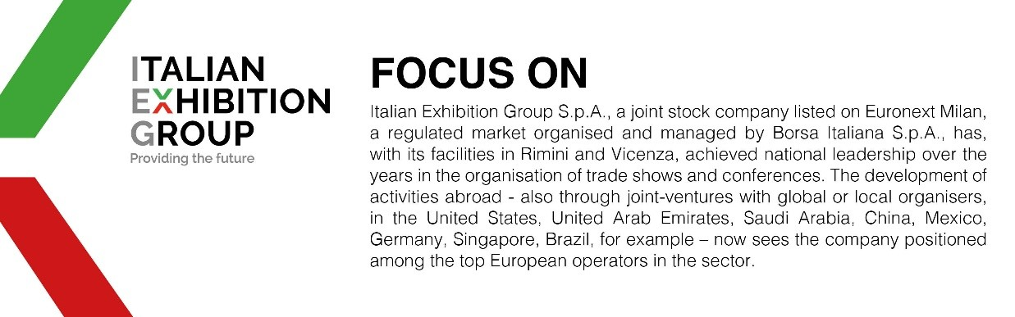
This press release contains forecast elements and estimates that reflect the management´s current opinions (´forward-looking statements´), particularly regarding future management performance, realization of investments, cash flow trends and the evolution of the financial structure. For their very nature, forward-looking statements have a component of risk and uncertainty, as they depend on the occurrence of future events. The effective results may differ (even significantly) from those announced, due to numerous factors, including, only by way of example: food service market and tourist flow trends in Italy, gold and jewellery market trends, green economy market trends; the evolution of raw material prices; general macroeconomic conditions; geopolitical factors and evolutions in the legislative framework. Moreover, the information contained in this release, does not claim to be complete, and has not been verified by independent third parties. Forecasts, estimates and objectives contained herein are based on the information available to the Company as at the date of this release.

