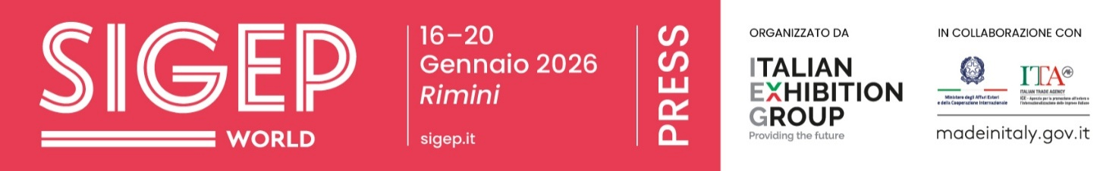

Press Note
SIGEP DAILY NEWS – Monday January 19th 2026

SIGEP CELEBRATES THE 10 ITALIAN PASTRY CHEFS AT THE PANETTONE WORLD CUP
SIGEP World celebrates the 10 Italian pastry chefs who will participate in the Panettone World Cup final, scheduled for November 7 and 8 in Milan. The final round of the Italian competition took place at the Rimini Fair with two categories. In the "Traditional Panettone" category, the finalists were Riccardo Manduca (Aprilia, LT), Roberto Moreschi (Chiavenna, SO), Fiorenze Ascolese (San Valentino Torio, SA), Luigi Vetrella (Macerata, Campania, CE), and Matteo Papanice (Castellana Grotte, BA). In the "Chocolate Panettone" category, the finalists were Armando Pascarella (San Felice a Cancello, CE), Pompilio Giardino (Ariano Irpino, AV), Luigi Avallone (Quarto, NA), Andrea Ceracchi (Cori, LT), and Alessandro Slama (Ischia). During the competition, all pastry chefs had to create the best original recipe for artisanal Milanese panettone, which calls for wheat flour, sugar, butter, egg yolks, salt, orange paste, orange zest, lemon zest, honey, vanilla, malt, malt extract, malt flour, sultanas, candied orange cubes, and candied citron cubes. The Italian selection represents a key stage in an international journey involving pastry chefs from Europe, the Americas, and Asia, which will culminate in Milan with the sixth annual Panettone World Cup final.

FROM BEAN TO BAR: THE BEAN TO BAR ASSOCIATION PUSHES ARTISAN CHOCOLATE
Creating a cocoa culture, just as with wine or coffee, to appreciate its complexity and flavor and, above all, to make the supply chain sustainable, from the initial producer to the final consumer. This topic was addressed in the talk "Artisanal bean-to-bar chocolate made in Italy: supply chain, opportunities, and new challenges," held at SIGEP World, which featured Giacomo Banchini (Banchini Parma 1879) and Johnny Spagnolo (founder of Aroko Chocolate). The discussion was organized by the Bean to Bar Chocolate Association Italy, which brings together artisanal producers interested in the entire process "from bean to bar," promoting the quality, traceability, and sustainability of chocolate. It has approximately 30 active members throughout the country. Chocolate in Italy has a market estimated at between €2.4 and €2.6 billion.
Despite the sharp increase in international cocoa prices—which rose by more than 80% between 2023 and 2024, reaching the highest level in the last forty years in 2025—the artisanal and premium segment is showing stable growth (+5-6% in 2024 according to IRI). Italy exports approximately €420 million worth of cocoa and chocolate products (+4% over 2024), with France, Germany, the USA, and the United Kingdom as the main destination markets.

BAKERIES, PIZZAS, FOCACCIA, AND DESSERTS ACCOUNT FOR 60% OF REVENUE
Pizzas, focaccias, and desserts account for 60% of bakeries' revenue, while bread—despite accounting for 62.5% of production in volume—still accounts for 40%, a slight decline from 44% in 2023, but offset by an increase in the former category (+3.3% compared to two years ago). This data emerged during the meeting "The consumer has changed. And the baker?" held at SIGEP World—underway at the Rimini Expo Center until tomorrow, January 20th — which analyzed the evolution of consumer habits and their impact on the baking sector, through a preview of the Cerved research. Large-scale food retail has strengthened, with revenues growing 2.8% in 2025 compared to the previous year, reaching €130 billion. While the restaurant industry, despite growing (+3.0%), has been impacted by increased price pressure, reaching nearly €100 billion. In bread consumption, the artisanal segment saw a modest decline (-1.9% between 2023 and 2025). In terms of the production network, the number of bakeries in Italy fell to 18,201 in 2025 (-1.6%), a sign of a market undergoing transformation rather than contraction. And 7% of bakeries have more than two local branches, with Lombardy and Tuscany leading the way in chain-based organization. In the discussion, Alberto Molinari, president of AIBI, and Palmino Poli, president of ASSITOL, emphasized the need to accompany these changes with organizational and technological innovation, safeguarding the supply chain's identity and value. Maria Maltese, curator of the research, emphasized how technology, new formats, and skills are reshaping the role of the baker, increasingly focused on sustainability, diversification, and consumer relations.

600,000 CELIAC PEOPLE IN ITALY AND ONE IN TWO ITALIANS DEFINES THEMSELVES LACTOSE INTOLERANT
In Italy, there are an estimated 600,000 celiacs, and more generally, one in two Italians can be defined as lactose intolerant. These figures emerged from the talk "The sweets supply chain facing new consumer demands," organized by Fipe at SIGEP World, currently underway at the Rimini Expo Center until tomorrow, January 20th. The figures were provided by the "Gluten-Free Eating Out" association and AILI (Italian Association of Lactose Intolerants). The talk focused on the need for eating out to adapt to potential customers, respecting production safety, controls, and more generally any type of contamination. The event program, moderated by Sauro Angelini, featured speakers: Carlotta Fabbri (president of the UIF ice cream producers' group), Michela Noli (contact person for the gluten-free eating out program), Maria Sole Facioni (president of AILI), Paolo Brunelli (ice cream maker), Roberto Calugi (FIPE general director), and Denis Preite (FIPE-Rimini president).

PRESS CONTACT ITALIAN EXHIBITION GROUP | media@iegexpo.it
head of corporate communication & media relation: Elisabetta Vitali|
press office manager: Marco Forcellini, Pier Francesco Bellini | international press office coordinator: Silvia Giorgi | press office coordinator: Luca Paganin | press office specialist: Nicoletta Evangelisti, Mirko Malgieri
MEDIA AGENCY SIGEP World: Mind The Pop
Martina Vacca: martina@mindthepop.it, mob. +39 339 748 5994; Fabrizio Raimondi: fabrizio@mindthepop.it, mob. +39 335 389 848; Benedetto Colli: benedetto@mindthepop.it, mob. 380 371 2272; Stefano Chiossi: stefano@mindthepop.it, mob. + 39 388 739 4358.

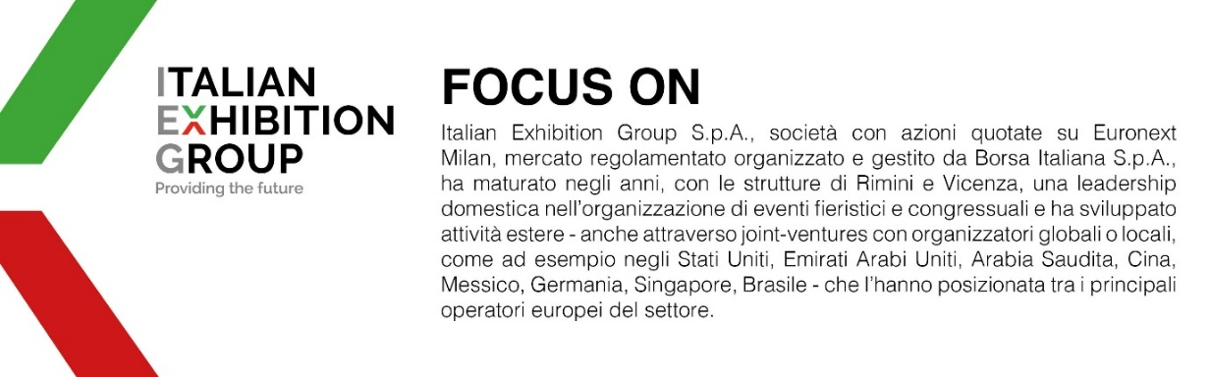
Il presente comunicato stampa contiene elementi previsionali e stime che riflettono le attuali opinioni del management (“forward- looking statements”) specie per quanto riguarda performance gestionali future, realizzazione di investimenti, andamento dei flussi di cassa ed evoluzione della struttura finanziaria. I forward-looking statements hanno per loro natura una componente di rischio e incertezza perché dipendono dal verificarsi di eventi futuri. I risultati effettivi potranno differire anche in misura significativa rispetto a quelli annunciati, in relazione a una pluralità di fattori tra cui, a solo titolo esemplificativo: andamento del mercato della ristorazione fuori casa e dei flussi turistici in Italia, andamento del mercato orafo - gioielliero, andamento del mercato della green economy; evoluzione del prezzo delle materie prime; condizioni macroeconomiche generali; fattori geopolitici ed evoluzioni del quadro normativo. Le informazioni contenute nel presente comunicato, inoltre, non pretendono di essere complete, né sono state verificate da terze parti indipendenti. Le proiezioni, le stime e gli obiettivi qui presentati si basano sulle informazioni a disposizione della Società alla data del presente comunicato.

