Press Note
SIGEP DAILY NEWS – Sunday January 18th 2026
LUXURY HOTEL BREAKFASTS INCREASINGLY SOUGHT-AFTER: EXPERIENCES REACH UP TO 55 EUROS
Hotels are no longer just for sleeping. This is evidenced by the figures presented at the conference “The Hotel: The New Potential Market for the Food World,” held at SIGEP World. Participants in the debate included Carlo Meo (Politecnico di Milano), Michele Cannone (Lavazza), and Stefano Moretti (Délifrance). Today, breakfast and hotel catering generate volumes that exceed those of a single local venue. While 15% of Italians do not eat breakfast or consume it in less than five minutes, those who choose it as an “experience” can spend anywhere from 10 to over 55 euros. These peaks are linked to luxury hôtellerie, often accompanying stays costing 800 euros per night. The hotel is thus becoming a place of continuous consumption, from breakfast to all-day dining, capable of attracting both global and local brands.

THE ROLE OF THE BARISTA? IRREPLACEABLE
At SIGEP World, currently taking place until January 20 at the Rimini Expo Centre, a discussion organized by Comunicaffè focused on the relationship between the barista profession and super-automatic machines. This technology provides concrete support for daily work, improving efficiency, quality, and sustainability, but according to the findings, it can never replace the role of the barista, who remains central to the relationship and the consumption experience. In this scenario, a more specialized model will emerge, capable of managing technology and maximizing the relationship with the customer. During the debate, Maurizio Giuli (CSO of Simonelli Group) framed the issue within different consumption models, highlighting how technology and tradition tend to converge today to meet market needs. Antonio Malvasi, a bar management instructor, recalled the importance of innovation capable of simplifying work without losing the emotional and social dimension of the bar. Andrea Pozzolini (CEO of Rhea Vendors Group) emphasized the value of the balance between automation and experience, with the barista as a key figure of expertise and culture. Michele Mastrocola (Director Partner Channel) spoke about the evolution of the operating model, in which technology reduces variability and frees up time for the relationship with the customer. Francesco Sanapo, multi-award-winning Italian barista and entrepreneur, brought the practical experience of coffee shops, where innovation helps manage staff shortages and rethink the role of the barista in an increasingly experiential way.

CIRCANA: ITALIAN OUT-OF-HOME SPENDING REACHES 71 BILLION EUROS (+12% VS. 2019)
Out-of-home visits (those entering a public establishment) remain below 2019 levels (15 billion, -4.2%), but overall spending is growing (71 billion euros, +12%), with an average receipt price of 4.74 euros (+17%), partly due to inflation. This data emerged from the talk “The State of the Art of Out-of-Home Consumption in Italy,” organized by Circana at SIGEP World, the event hosted by the Italian Exhibition Group, running at the Rimini Expo Centre until Tuesday, January 20.
According to Matteo Figura (Executive Director of Foodservice Italy at Circana), overall figures remain high: in the past year, Italians spent 154 billion euros on food and beverages. Out-of-home spending remained stable, representing 46% of total expenditure, while “in-home” spending (supermarkets) accounted for 54%, valued at 84 billion euros. Finally, after fast food, gelato parlors are the category showing the highest growth in visits compared to 2024, while bakery products, coffee, and pizza are the "healthiest" segments, testifying to the importance of breakfast as the preferred consumption moment for Italians.
In any case, the Italian consumer enters 2026 with compressed spending margins due to low wages, uncertainty regarding the international geopolitical context, and price hikes on essential goods. The primary concern for 71% remains the cost of living and purchasing power. Anxiety related to US government actions is also rising: in October, 57% were worried, compared to barely 30% last January; furthermore, 51% of respondents believe that tariffs will cause restaurant prices to rise further.

GELATO WORLD MASTERS: CALABRIAN SALVATORE RAVESE TRIUMPHS. ZANDONÀ (PADUA) AND CINELLI (BOLOGNA) ROUND OUT THE PODIUM
During SIGEP World, held at the Rimini Expo Centre until January 20, the Italian Final of the Gelato Festival World Masters took place—the most prestigious international competition for individual gelato makers. Winning the title of Best Italian Gelato Maker 2026 was Salvatore Ravese (Garden Gelateria in Gioia Tauro), taking first place with the flavor “Kiss of the Two Seas”. Second place went to Guido Zandonà (Gelato che Meriti in Padua) with “Salter Caramel with Superior Butter”, followed by Danilo Cinelli (Delizie Bolognesi in Bologna) in third place with the sorbet “Bora Bora”. Fourth position was awarded to Elisabeth Stolz (Osteria Hubenbauer in Varna, Bolzano) with “The Treasures of Our Mountains”. These four masters will represent Italy at the 2026 World Final. The competition, organized in collaboration with Carpigiani and the Italian Exhibition Group, concludes a five-year journey of national and international selections.

PRESS CONTACT ITALIAN EXHIBITION GROUP | media@iegexpo.it
head of corporate communication & media relation: Elisabetta Vitali|
press office manager: Marco Forcellini, Pier Francesco Bellini | international press office coordinator: Silvia Giorgi | press office coordinator: Luca Paganin | press office specialist: Nicoletta Evangelisti, Mirko Malgieri
MEDIA AGENCY SIGEP World: Mind The Pop
Martina Vacca: martina@mindthepop.it, mob. +39 339 748 5994; Fabrizio Raimondi: fabrizio@mindthepop.it, mob. +39 335 389 848; Benedetto Colli: benedetto@mindthepop.it, mob. 380 371 2272; Stefano Chiossi: stefano@mindthepop.it, mob. + 39 388 739 4358.

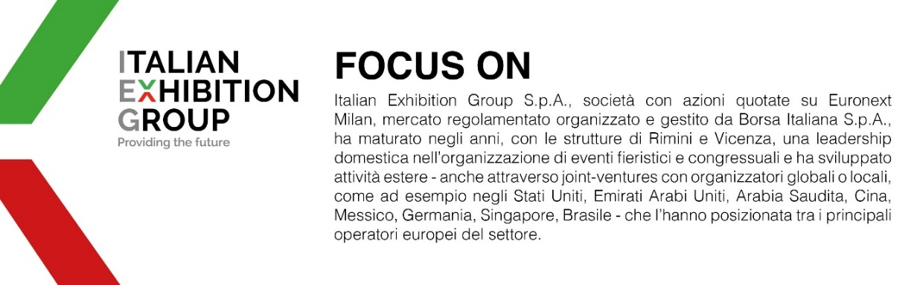
This press release contains forecast elements and estimates that reflect the management´s current opinions (´forward-looking statements´), particularly regarding future management performance, realization of investments, cash flow trends and the evolution of the financial structure. For their very nature, forward-looking statements have a component of risk and uncertainty, as they depend on the occurrence of future events. The effective results may differ (even significantly) from those announced, due to numerous factors, including, only by way of example: food service market and tourist flow trends in Italy, gold and jewellery market trends, green economy market trends; the evolution of raw material prices; general macroeconomic conditions; geopolitical factors and evolutions in the legislative framework. Moreover, the information contained in this release, does not claim to be complete, and has not been verified by independent third parties. Forecasts, estimates and objectives contained herein are based on the information available to the Company as at the date of this release.

