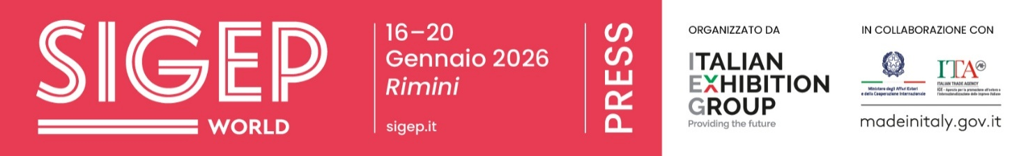

Press Note
SIGEP DAILY NEWS – Saturday January 17th 2026

FIPE: ITALIAN BARS ARE VALUED NEARLY €24 BILLION WITH AN AVERAGE BILL OF €4.20
Nearly 6 billion visits to Italian bars in 2025 (44% for breakfast, 29% during breaks, 14% for aperitifs, 6% for lunch, 3% for dinner, and 4% for after-dinner drinks) and a market value of €23.8 billion, with an average bill of just €4.20, and a network of 152,000 establishments spread across the country: three out of four Italian municipalities have at least one bar, a business open an average of 14 hours a day and often seven days a week. This is revealed by the analysis by Fipe-Confcommercio on Tradelab data presented at SIGEP World 2026, underway at the Rimini Expo Centre until Tuesday, January 20th, in the round table discussion 'The future of the Italian bar (and prospects for 2026)'.
The sector employs 367,900 people, including 284,606 employees, with a strong female (58.9%) and youth (41.3% under 30) presence, as well as a significant proportion of foreign workers (20.8%).
Over half of the workforce (57.5%) has permanent contracts; 148,830 of the 152,650 bars are independent businesses, and only 3,820 belong to chains, a model that reflects the family-run nature of Italian bars. The balance between openings and closures in the first three quarters of 2025 was negative (-2,884 units), and the business survival rate five years after opening is 53%.

RESTAURANT MARKET: ITALY AND SPAIN KEEPING PACE, DIGITAL ORDERS BOOM
Over the past eight years, spending on online foodservice orders in the five main European markets has risen from 11.5 to a staggering 39.6 billion euros. This is the finding from SIGEP World, running until Tuesday, January 20th at Rimini Expo Centre and organized by Italian Exhibition Group, where Circana outlined the European foodservice landscape in the talk "The European Restaurant Market – Opportunities and Perspectives."
The analysis reveals a two-speed Europe: while the North is struggling, the South is keeping pace, with Italy, France, and Spain recording marginal declines. The real revolution, however, is digital: for both delivery and takeout from public establishments, online orders are simplifying time and payment. At the same time, optimism for the sector's future is supported by the strengthening of the return to the office and the willingness of consumers to continue enjoying the pleasures of eating out, despite cutting other expenses.

THE MOST INNOVATIVE FOODSERVICE START-UPS AWARDED AT SIGEP WORLD
During SIGEP World 2026, the most innovative foodservice start-ups were honored as part of the Lorenzo Cagnoni Innovation Awards, promoted by Italian Exhibition Group in collaboration with ANGI and ITA Agenzia. The awards highlighted the leading innovative foodtech excellences that also emerged within the International Startup Village, which brought together 20 Italian and international projects. The awards covered the entire foodservice supply chain, from sustainability to digital innovation, from professional kitchen technologies to ingredients, packaging, and new business models. Illy Caffè, SMEG, and Modular received awards for sustainability. Burroliva, Molino Grassi, and Hacco were awarded In the organic and free-from category.
Krupps, Winterhalter, and Robomagister stood out for digital innovation and artificial intelligence. In the equipment and technology category, awards went to Margot, GI.METAL, and Think:Water. In the frozen and ready-made category, awards went to Il Panificio di Camillo, Forno d’Asolo, and Sammontana – Tre Marie. In the ingredients and semi-finished products category, awards went to Campmix, Louis François, and Torrcaffè, while in the packaging category, awards went to Polo Plast, SPL Industries, and Lesaffre Italia.

ITALY DEFENDS ITS WORLD TITLE AT THE GELATO WORLD CUP
The 11th edition of the Gelato World Cup, the world's most prestigious team competition dedicated to artisanal gelato, is underway at SIGEP World 2026, held at the Rimini Expo Center until January 20th. The event, organized by Italian Exhibition Group, brings together 12 teams from Asia, Europe, and the Americas, selected through national and international processes. After the first day, which featured six teams, the competition continues with technical and artistic challenges. Teams compete in tasks ranging from the Mystery Box to chocolate sculpture, all the way to the Grand Buffet Finale, judged by international artistic and technical juries. The journey to the world title, currently held by Italy after its victory at SIGEP 2024, will conclude on Tuesday, January 20th with the Award Ceremony.

RESTAURANTS, THE NEW BUSINESS CARD FOR LUXURY HOTELS
Restaurants as a strategic lever for redefining the identity of luxury hotels: this is the underlying theme of Luxury Hotel Food Experience, the talk presented at SIGEP World, currently underway at the Rimini Expo Center. Among the speakers — moderated by Federico De Cesare Viola, director of Food&Wine Italia — were Ilaria Carini, Operations Manager of the Rome Cavalieri – A Waldorf Astoria Hotel; Cristina Mottironi, professor at Bocconi University; and Gennaro Esposito, Michelin-starred chef and owner of the Torre del Saracino.
Today, approximately 40% of hotels open their restaurants to external guests: a decision that impacts profitability but, above all, their perceived positioning. The hotel thus becomes an independent destination, a cultural hub, and an urban "third space," capable of attracting locals. This development also helps stabilize fluctuations in the tourism market, especially seasonality.

PRESS CONTACT ITALIAN EXHIBITION GROUP | media@iegexpo.it
head of corporate communication & media relation: Elisabetta Vitali|
press office manager: Marco Forcellini, Pier Francesco Bellini | international press office coordinator: Silvia Giorgi | press office coordinator: Luca Paganin | press office specialist: Nicoletta Evangelisti, Mirko Malgieri
MEDIA AGENCY SIGEP World: Mind The Pop
Martina Vacca: martina@mindthepop.it, mob. +39 339 748 5994; Fabrizio Raimondi: fabrizio@mindthepop.it, mob. +39 335 389 848; Benedetto Colli: benedetto@mindthepop.it, mob. 380 371 2272; Stefano Chiossi: stefano@mindthepop.it, mob. + 39 388 739 4358.

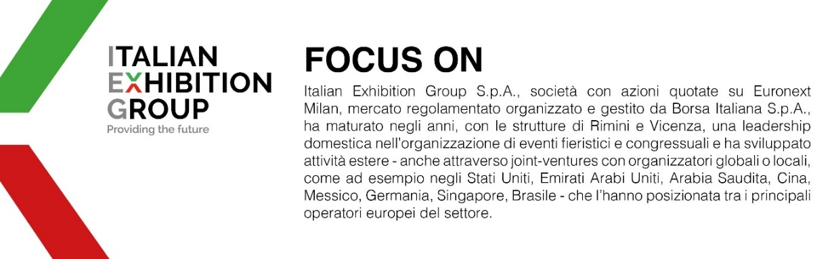
This press release contains forecast elements and estimates that reflect the management´s current opinions (´forward-looking statements´), particularly regarding future management performance, realization of investments, cash flow trends and the evolution of the financial structure. For their very nature, forward-looking statements have a component of risk and uncertainty, as they depend on the occurrence of future events. The effective results may differ (even significantly) from those announced, due to numerous factors, including, only by way of example: food service market and tourist flow trends in Italy, gold and jewellery market trends, green economy market trends; the evolution of raw material prices; general macroeconomic conditions; geopolitical factors and evolutions in the legislative framework. Moreover, the information contained in this release, does not claim to be complete, and has not been verified by independent third parties. Forecasts, estimates and objectives contained herein are based on the information available to the Company as at the date of this release.

