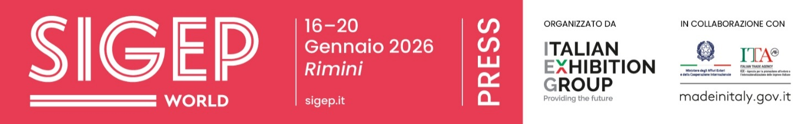

Press Note
SIGEP DAILY NEWS
Friday, January 16th2026

SIGEP WORLD CELEBRATES THE RECOGNITION OF ITALIAN CUISINE AS UNESCO HERITAGE
The extended Italian agri-food chain generates a value of 707 billion euros according to Coldiretti, making food the country's primary source of wealth. This prestige led to the recognition of Italian Cuisine as UNESCO Intangible Cultural Heritage last December, a milestone celebrated today during SIGEP World. Organized by Italian Exhibition Group, the event is held at the Rimini Expo Centre from today until Tuesday, January 20th. The roundtable featured Pierluigi Petrillo (Director of the UNESCO Chair at Unitelma Sapienza in Rome), author of the successful nomination dossier. He outlined the key pillars of the work that led UNESCO, for the first time in its history, to recognize a national cuisine as World Heritage. He also discussed future challenges, noting that within five years, Italy must meet the objectives set in the candidacy to maintain this prestigious status. The talk, moderated by Federico De Cesare Viola, also included Maddalena Fossati (Editor-in-chief of La Cucina Italiana), Giacomo Bullo (Communication Manager at ALMA), Sergio Colalucci (President of the Gelato World Cup), Sal De Riso (President of AMPI), and Michelin-starred chef Gennaro Esposito.

SIGEP VISION TALK: OUT-OF-HOME VISITS, ITALY AND SPAIN HOLD STEADY. CHINA BOOMS
During the SIGEP Vision talk "The New Era of Hybrid Foodservice Experiences," four international experts analyzed the evolution of the foodservice industry. In the panel moderated by Flavia Morelli (Group Exhibition Manager Food and Bevearge division at IEG), Edurne Uranga, Vice President Foodservice Europe at Circana, provided a global overview: while the number of out-of-home visits, in recent years, has declined in several countries Italy and Spain are relatively bucking the trend, while a significant positive spike is emerging in China. The talk, held at SIGEP World (running until January 20th at the Rimini Expo Centre), also featured Nicola Greco (Co-founder and CEO of RivaReno Gelato), Stacey Kane (Fractional Chief Marketing Officer), and Sabyasachi Gorai (Owner of Fabrica by Chef Saby).

MAGNETIC REFRIGERATION REVOLUTIONIZES BEVERAGE COOLING: ESTIMATED EFFICIENCY INCREASE OF +50%
Magnetic refrigeration can reduce electricity consumption by 30%, with an efficiency potential exceeding 50%. This emerged from the talk "Fresh thinking: unlocking growth through the power of cooling innovation" held today at SIGEP World. Alessandro Pastore, professor at the Bologna Business School and co-founder of Camfridge Ltd, joined journalist Emma Jane Barltrop to present real-world data on the first commercial prototypes of solid-state magnetic refrigeration beverage coolers. Drawing on data from scientific papers and industry conferences, the presentation highlighted that compared to gas compression systems, electricity consumption can be reduced by 30% with an efficiency potential over 50%. In competitive environments such as supermarkets and retail outlets, this innovation allows for cooler designs with larger display areas and lower energy consumption, with estimated purchase costs for large quantities already proving competitive. Furthermore, these units can be powered by small batteries or solar panels.

PRESS CONTACT ITALIAN EXHIBITION GROUP | media@iegexpo.it
head of corporate communication & media relation: Elisabetta Vitali|
press office manager: Marco Forcellini, Pier Francesco Bellini | international press office coordinator: Silvia Giorgi | press office coordinator: Luca Paganin | press office specialist: Nicoletta Evangelisti, Mirko Malgieri
MEDIA AGENCY SIGEP World: Mind The Pop
Martina Vacca: martina@mindthepop.it, mob. +39 339 748 5994; Fabrizio Raimondi: fabrizio@mindthepop.it, mob. +39 335 389 848; Benedetto Colli: benedetto@mindthepop.it, mob. 380 371 2272; Stefano Chiossi: stefano@mindthepop.it, mob. + 39 388 739 4358.

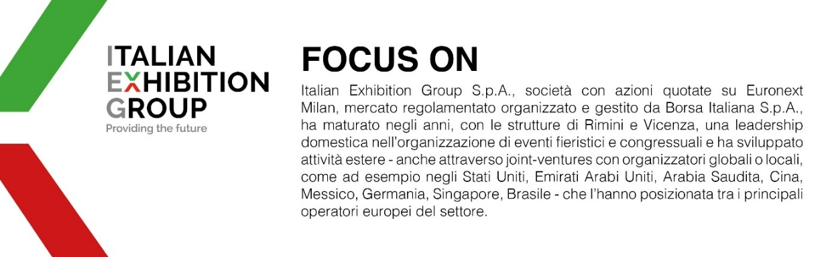
This press release contains forecast elements and estimates that reflect the management´s current opinions (´forward-looking statements´), particularly regarding future management performance, realization of investments, cash flow trends and the evolution of the financial structure. For their very nature, forward-looking statements have a component of risk and uncertainty, as they depend on the occurrence of future events. The effective results may differ (even significantly) from those announced, due to numerous factors, including, only by way of example: food service market and tourist flow trends in Italy, gold and jewellery market trends, green economy market trends; the evolution of raw material prices; general macroeconomic conditions; geopolitical factors and evolutions in the legislative framework. Moreover, the information contained in this release, does not claim to be complete, and has not been verified by independent third parties. Forecasts, estimates and objectives contained herein are based on the information available to the Company as at the date of this release.

