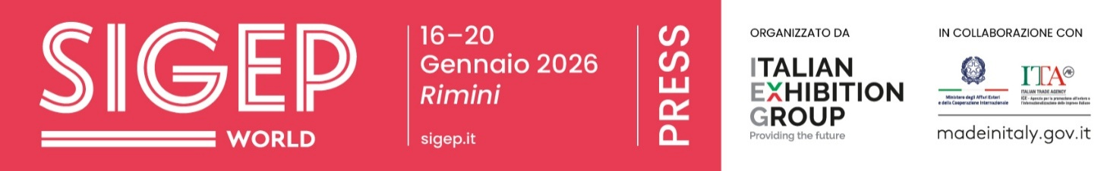
Press release
SIGEP WORLD OPENS ITS DOORS: GELATO, PASTRY, CHOCOLATE, COFFEE, BAKERY, AND PIZZA SUPPLY CHAINS FEATURING AT RIMINI EXPO CENTRE UNTIL TUESDAY
- At the opening ceremony, Alessandra Locatelli, Minister for Disabilities, Michele de Pascale, President of the Emilia-Romagna Region, Lorenzo Galanti, Director General of ICE Agency, Juri Magrini, Councillor for Economic Activities of the Municipality of Rimini, and Maurizio Ermeti, President of Italian Exhibition Group.
- Unveiling the latest foodservice innovations and trends: from companies offering mobile ice cream shops to those showcasing exotic, alcoholic, dark beer, functional, and vegan flavours.

Rimini, 16 January 2026 – The 47th edition of SIGEP World – The World Expo for Foodservice Excellence – opened this morning at Rimini Expo Centre and will run until Tuesday, 20 January. This Italian Exhibition Group event will showcase the best of out-of-home foodservice, from production to technology.
Centre stage are the gelato, pastry, chocolate, coffee, bakery and pizza industries, with over 1,300 exhibitors showcasing the best of Italian manufacturing. This year, international presence has grown by 33% compared to last year. ​Rimini is expecting buyers from 75 countries, with a growing international presence, and India as the Guest Country for 2026.
OPENING CEREMONY
Special guests at the inaugural ceremony included Alessandra Locatelli, Minister for Disabilities, Michele de Pascale, President of the Emilia-Romagna Region, Lorenzo Galanti, Director General of the Italian Trade Agency, Juri Magrini, Councillor for Economic Activities of the Municipality of Rimini, and Maurizio Renzo Ermeti, President of Italian Exhibition Group. Alessandra Locatelli, Minister for Disabilities, began by saying: “I’d like to thank Sigep World and Italian Exhibition Group for this wonderful and important occasion, which demonstrates that innovation, quality, and inclusion can and must go hand in hand. ​Work is a powerful tool for dignity, autonomy, and participation, as demonstrated by the presence of Anffas di Mirandola, which provides daily opportunities for greater participation to many young people. ​I had the pleasure of visiting several stands that offer opportunities to everyone, showcasing their talents and skills. ​This is the real challenge we face, both now and in the future, and we must all continue to invest in this direction to strengthen our communities and the entire country”.
The President of the Emilia-Romagna Region, Michele de Pascale, continued: “Sigep World is one of the most prestigious events in the regional trade fair calendar and a significant international platform for promoting Emilia-Romagna’s expertise. ​Events of this calibre strengthen our region’s position as a global leader in innovation, quality, and business culture, showcasing our skills, production chains, and regional excellence. ​The ability to attract operators, buyers and visitors from around the world is a strategic factor for Emilia-Romagna’s economic development and reputation in international markets”.
Lorenzo Galanti, Director General of ICE, the Italian Trade Agency, explained: “ICE enthusiastically supports this 47th edition of SIGEP, as a strategic platform for internationalisation. ​We do this by bringing over 500 foreign buyers from key global markets, supporting 20 national and international start-ups in the Sustainability District, and coordinating the Guest Country 2026 project, which will showcase India with the involvement of ICE offices in New Delhi and Mumbai, opening up significant opportunities in one of the world’s most dynamic markets. ​We also place great emphasis on initiatives related to the Mattei Plan for Africa, including a programme to welcome delegates from 21 African coffee cooperatives, accompanied by thematic talks on the relevant markets. ​The collaboration with SIGEP exemplifies a virtuous model of integrated promotion: the trade fair, the institution, and the production system work together to create tangible opportunities in global markets. ​Made in Italy flavours have everything they need to continue conquering international markets”.
Juri Magrini, Councillor for Economic Activities at Rimini City Council, added: “In a delicate and uncertain global climate, this new edition of SIGEP World is an opportunity to look to the future, focusing on two key words: innovation and internationalisation. ​For the country and local areas like ours, where services and hospitality are key drivers of development, investing means enhancing a wealth of productive excellence and craftsmanship, while also anticipating the trends and needs of tomorrow’s consumers, and engaging with the wider world. ​Innovation and internationalisation are the guiding principles of Italian Exhibition Group, which, through SIGEP World, reaffirms Rimini as a key reference point and launchpad for the calendar of major Italian and European exhibitions.”
Maurizio Ermeti, President of Italian Exhibition Group, said: “In recent years, we have strengthened the role of trade fairs as hubs for our industrial communities. ​Today, they serve as platforms for international opportunities, information, and training. ​SIGEP World is also expanding on many fronts: our pavilions now showcase a wider range of Italian and international excellence than ever before. ​SIGEP is already present in Singapore, China, and from this year also in the United States. ​Today, we welcome a large delegation from India, representing its institutions and buyers. ​The guidelines for the global development of the SIGEP brand are very clear: to strengthen its role as a leading global platform for all the supply chains involved, with a major central event here in Rimini and a network of supporting events in countries strategic for Made in Italy”.
Also present at the fair was Roberta Frisoni, the Regional Councillor for Tourism, Sport and Commerce, who commented: “In almost fifty years of activity, Sigep has established itself as a unique event in Italy, renowned for its ability to bring together the creativity, flair and sustainable proposals of thousands of professionals. It is a source of pride and satisfaction for us to have witnessed the birth and growth of this event in Emilia-Romagna. ​This 47th edition has never been more international, generating significant hotel occupancy and confirming Rimini’s role as a dynamic hub for the regional MICE sector. Rimini is ideally positioned for major events, with direct access to Fellini Airport and high-speed rail, complemented by a wide variety of dining and entertainment options.”
Visitors can explore all the latest foodservice innovations and trends. For example, in the gelato sector alone, companies are showcasing everything from mobile outlets – configurable as either ice cream shops or beverage stations – to bring the best of Made in Italy products to any location, to those presenting exotic, rich, and aromatic flavours, perfect for warm climates, offering an ice cream-like experience without the need for churning. ​There are also alcoholic ice creams, dark beer versions, functional ice creams for energising breakfasts and snacks, and 100% plant-based vegan options made with fructose, offering a practical and quick way to enjoy high-quality ice cream.

ITALIAN EXHIBITION GROUP PRESS CONTACTS | media@iegexpo.it
head of corporate communication & media relations: Elisabetta Vitali|
press office manager: Marco Forcellini, Pier Francesco Bellini | international press office coordinator: Silvia Giorgi | press office coordinator: Luca Paganin | press office specialist: Nicoletta Evangelisti, Mirko Malgieri
MEDIA AGENCY SIGEP World: Mind The Pop
Martina Vacca: martina@mindthepop.it, mob. +39 339 748 5994; Fabrizio Raimondi: fabrizio@mindthepop.it, mob. +39 335 389 848; Benedetto Colli: benedetto@mindthepop.it, mob. 380 371 2272; Stefano Chiossi: stefano@mindthepop.it, mob. + 39 388 739 4358.

Martina Vacca: martina@mindthepop.it, mob. +39 339 748 5994; Fabrizio Raimondi: fabrizio@mindthepop.it, mob. +39 335 389 848; Benedetto Colli: benedetto@mindthepop.it, mob. 380 371 2272; Stefano Chiossi: stefano@mindthepop.it, mob. + 39 388 739 4358.

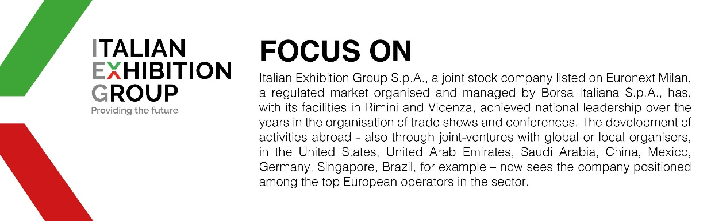

This press release contains forecast elements and estimates that reflect the management´s current opinions (´forward-looking statements´), particularly regarding future management performance, realization of investments, cash flow trends and the evolution of the financial structure. For their very nature, forward-looking statements have a component of risk and uncertainty, as they depend on the occurrence of future events. The effective results may differ (even significantly) from those announced, due to numerous factors, including, only by way of example: food service market and tourist flow trends in Italy, gold and jewellery market trends, green economy market trends; the evolution of raw material prices; general macroeconomic conditions; geopolitical factors and evolutions in the legislative framework. Moreover, the information contained in this release, doe not claim to be complete, and has not been verified by independent third parties. Forecasts, estimates and objectives contained herein are based on the information available to the Company as at the date of this release.

