Press release

SIGEP WORLD 2025 RAISES THE CURTAIN: FROM TOMORROW, THE GLOBAL FOODSERVICE INDUSTRY AT RIMINI EXPO CENTRE
- From Saturday January 18th to Wednesday January 22nd, the 46th edition of the event dedicated to gelato, pastry, chocolate, coffee, bakery and pizza

- Agriculture Minister Francesco Lollobrigida, Italian Exhibition Group President Maurizio Ermeti, Rimini Mayor Jamil Sadegholvaad, Emilia-Romagna Regional Tourism Councillor Roberta Frisoni, and Italian Federation of Public Establishments (FIPE) President Lino Stoppani at the cutting of the ribbon

sigep.it

Rimini, 17th January 2025 – The 46th edition of SIGEP World - The World Expo for Foodservice Excellence, the international event of reference for the gelato, pastry, chocolate, coffee, bakery and pizza supply chains, organized by Italian Exhibition Group (IEG), opens its doors tomorrow at Rimini Expo Centre.

THE OPENING CEREMONY
The opening ceremony of the 46th edition of SIGEP World, scheduled for Saturday 18th at 11.30 am in the Vision Plaza – South Hall, will be attended by Minister of Agriculture Francesco Lollobrigida, Italian Exhibition Group President Maurizio Ermeti, Rimini Mayor Jamil Sadegholvaad, Emilia-Romagna Regional Tourism Councillor Roberta Frisoni and the President of the Italian Federation of Public Establishments (FIPE), Lino Stoppani.

SIGEP World is the global leader for the foodservice sector with 138,000 square meters of exhibition space, 30 halls and 1,300 exhibiting brands. An extraordinary opportunity to meet more than 3,000 international buyers, thanks also to the presence of Saudi Arabia as country partner, a strategic nation for hospitality and out-of-home.

KEYWORDS: TECHNOLOGY AND THE FUTURE
SIGEP World 2025 excels for its considerable focus on new trends in foodservice, presenting a comprehensive exhibition offer of the industry's main supply chains with a further expansion to the pizza segment, which this year will be more consolidated as one of the show’s key players.
With the launch of SIGEP Vision, the event becomes an important incubator for industry trends and acts as a global observatory on foodservice trends throughout the year, as well as a privileged vantage point for sector operators, companies and professionals. The prestigious collaborations initiated with major foodservice research companies have been important in this regard. The main new entries include the Sustainability District, a prominent new area dedicated to promoting virtuous practices in the coffee and cocoa supply chains, while another focal point of this edition will be Taste of Tomorrow, the project that celebrates innovation in the gelato world, thus defining the new frontiers of the gelato industry of the future. In addition, the Lorenzo Cagnoni Innovation Award for companies and start-ups, specifically for the sector’s most innovative start-ups with particular focus on categories such as Digital Innovation, Sustainability and Packaging. The Lorenzo Cagnoni Award is an important recognition for companies and start-ups that are driving change in the foodservice industry with creative and sustainable technological solutions.

A GLOBAL STAGE FOR THE FOODSERVICE BUSINESS
SIGEP World 2025 strengthens its international character with significant numbers: more than 520 top buyers from 79 countries have joined the Top Buyer Program, representing nations such as the United States, India, Canada, Brazil, Turkey and many others, including South America, Southeast Asia and the Gulf countries. More than 2,500 buyers from 15 countries are expected through the European Premium Program with Spain, Germany and France leading the way. Furthermore, SIGEP will host 40 international events with more than 60 speakers from around the world, confirming its central role in the foodservice panorama.

ARTISAN GELATO, PIZZA AND BREAD ON THE RISE, BOOM IN COFFEE MACHINE EXPORTS
In 2024, the artisan gelato sector grew at a European level, reaching 11 billion euros (1% more than in 2023). Italy confirmed its leading role with a turnover close to 3 billion euros and 39,000 outlets. The sector is evolving toward deseasonalization with more than 40% of gelato parlours open all year round and is expanding its offer to healthy gelato. Pastry is also showing positive growth with an expected 4-5% growth in 2024, thanks to leavened goods for special occasions, such as panettone (+7-10%). Italy's 17,500 pastry shops are increasingly embracing sustainability by using local ingredients and eco-friendly packaging.
On the pizza front, the sector remains solid considering that 2.7 billion pizzas are churned out each year in Italy alone and are increasingly popular among families and young people. Bread, a fundamental product for Italians, also registered a 1.5% growth in consumption and a total turnover of 13 billion euros. Demand is leaning toward “healthy” products with a preference for whole-grain breads with low glycaemic content made from ancient grains.
Lastly, Italian coffee shines on international markets with exports of 2.3 billion euros, consolidating Italy as the world's second largest exporter. The success of coffee machines stands out the most with exports accounting for 75% of a steadily growing total turnover. (Sources: UIF, ACOMAG, AIG, Confartigianato, Confesercenti, FIPE-Confcommercio, Demoskopea, ISTAT, TCI).

FOCUS ON SIGEP 2025
Dates: 18-22 January 2025; Organization: Italian Exhibition Group SpA; edition: 46th; frequency: annual; event: international trade show; entry: trade only; info: www.sigep.it

PRESS CONTACT SIGEP ITALIAN EXHIBITION GROUP
head of media relation & corporate communication: Elisabetta Vitali; press office manager: Marco Forcellini, Pierfrancesco Bellini; press office specialist: Mirko Malgieri
international press office coordinator: Silvia Giorgi; media@iegexpo.it

MEDIA AGENCY SIGEP: Mind The Pop
Martina Vacca: martina@mindthepop.it, mob. +39 339 748 4994; Fabrizio Raimondi: fabrizio@mindthepop.it, mob. +39 335 389 848; Benedetto Colli: benedetto@mindthepop.it, mob. 380 371 2272; Stefano Chiossi: stefano@mindthepop.it, mob. + 39 388 739 4358.
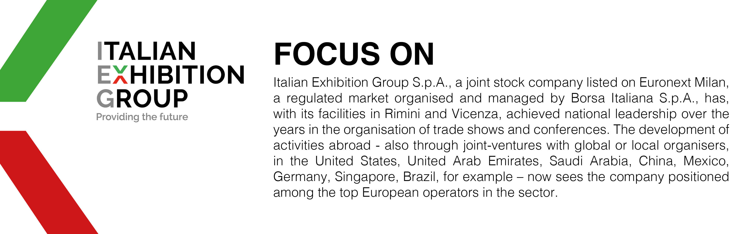

This press release contains forecast elements and estimates that reflect the management´s current opinions (´forward-looking statements´), particularly regarding future management performance, realization of investments, cash flow trends and the evolution of the financial structure. For their very nature, forward-looking statements have a component of risk and uncertainty, as they depend on the occurrence of future events. The effective results may differ (even significantly) from those announced, due to numerous factors, including, only by way of example: food service market and tourist flow trends in Italy, gold and jewellery market trends, green economy market trends; the evolution of raw material prices; general macroeconomic conditions; geopolitical factors and evolutions in the legislative framework. Moreover, the information contained in this release, does not claim to be complete, and has not been verified by independent third parties. Forecasts, estimates and objectives contained herein are based on the information available to the Company as at the date of this release.

