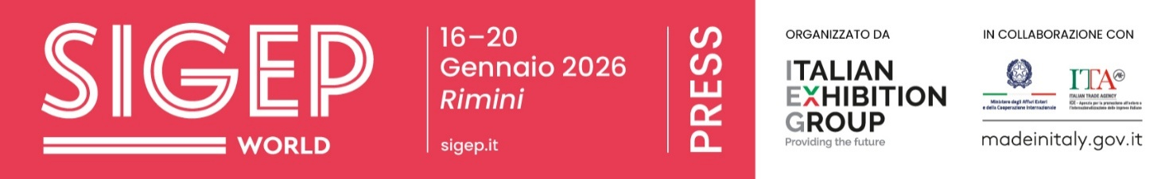

Press release no. 8
SIGEP WORLD 2026 INTERNATIONAL FOCUS: + 33% FOREIGN EXHIBITORS WITH INDIA AS GUEST COUNTRY

- From Friday 16 to Tuesday 20 January, SIGEP World returns to Rimini Expo Centre with 1,300 brands and a 33% increase in foreign exhibitors from 45 countries. ​Companies from Canada to Singapore make their debut, alongside collectives from Saudi Arabia, China, and Ukraine. ​India features as Guest Country, represented by a delegation of 50 buyers and institutional representatives.

- The Top Buyer Program brings 500 top buyers from 75 countries to Rimini, including chains, importers, and distributors.

- 26 international events scheduled, featuring over 50 international speakers.

- Looking ahead, SIGEP is expanding globally with SIGEP USA from 24–26 March in Las Vegas, followed by the SIGEP China roadshow in Shanghai this spring, and SIGEP Asia in Singapore in July

sigep.it
Rimini, 22 December 2025 — SIGEP World 2026 is set to become an increasingly international event, featuring 1,300 exhibiting brands from 45 countries and 500 top buyers from 75 nations. ​India confirmed as the guest country this year, following Saudi Arabia in 2025. Here are just some of the international developments at SIGEP World – The World Expo for Foodservice Excellence, the international exhibition for Gelato, Pastry, Chocolate, Bakery, Pizza and Coffee, curated by Italian Exhibition Group (IEG) and scheduled to take place at Rimini Expo Centre from Friday 16 to Tuesday 20 January. ​This event isn’t just about showcasing products and technologies; it brings together manufacturing excellence, innovation, and international markets under one roof.

EXPANDING OFFER, GROWING GLOBAL PARTICIPATION
SIGEP World 2026 will expand to 138,000 m² across 30 halls, featuring 1,300 brands that bring the best of Made in Italy to Rimini—from traditional supply chains to cutting-edge technologies. The fair will highlight a strong Italian presence with top drawer companies across the foodservice industry, while its international component grows by 33%, with 45 countries represented, all aiming to tap into the global confectionery and out-of-home markets.
Within this ever-expanding landscape, a select group of countries stands out. Backed by strong industrial capabilities and a high capacity for innovation, these nations—together with Italy—play a pivotal role in driving the sector’s core supply chains. Germany, Spain, France, China, Turkey, Belgium, Poland, the United States, Greece, and Denmark will be present at the fair, showcasing cutting-edge technologies, ingredients, products, and expertise that are set to influence global market trends and shape future strategies.
In addition to this scenario, the 2026 edition will welcome new participating countries, including Canada, Algeria, Ecuador, Estonia, Serbia, Singapore, Nepal, and the Czech Republic. National Pavilions—official country delegations that choose SIGEP World as a strategic platform to showcase their excellence—will also be featured at the fair. This year, Saudi Arabia, China, and Ukraine will be represented. In particular, Saudi Arabia — the 2025 guest country — will participate with the “Taste of Saudi Culture Pavilion”, showcasing 12 companies in Hall B1 – a dynamic hub with tastings and meetings, networking and encounters with leading coffee, tea, and date producers.

INDIA GUEST COUNTRY AT THE 2026 EDITION
For the 2026 edition, India will be the Guest Country, marking a particularly prominent presence at SIGEP World. The fair is expected to welcome a delegation of 50 leading buyers, alongside institutional representatives and exhibitors specialising in ice cream technology—a segment experiencing rapid growth within the Indian market.
This initiative stems from a wide-ranging international collaboration involving the ICE Offices in New Delhi and Mumbai, the Italian Embassy in New Delhi, the Indian Embassy in Rome, and major Indian institutions active in the agri-food industry.

THE BUYER PROGRAMME STRENGTHENS SIGEP WORLD’S GLOBAL REACH
SIGEP World’s enhanced international positioning is further reinforced by an ambitious incoming strategy. The Top Buyer Program will bring 500 buyers from 75 countries to Rimini, with particularly strong representation from the United States, India, Canada, Brazil, China, Turkey, the United Arab Emirates, and Singapore. Participating profiles include major foodservice chains, large-scale importers, and specialised distributors seeking cutting-edge technologies, products, and solutions aligned with evolving global market demands.
In parallel, SIGEP World will host a rich programme of high-level industry discussions. The 2026 edition will feature 26 international events, with contributions from over 50 international speakers, offering valuable insights for exhibitors and buyers alike.

A strong presence from leading international associations will also underscore the event’s global relevance. These include ACA (Airline Catering Association), CEOPPAN (Spanish Confederation of Bakery and Pastry Trades), FIFI (Forum of Indian Food Importers), HRAWI (Hotel and Restaurant Association of India), HPMF (Hospitality Purchasing Managers’ Forum, India), and OSSKiC (National Association of Chefs and Confectioners of Poland).

SIGEP WORLD’S GLOBAL STAGES
SIGEP World represents a truly international network developed by the Italian Exhibition Group to support companies in accessing key global markets. In November, the first stage of this global journey took place in Madrid, with a roadshow hosted by the Italian Embassy and organised in collaboration with the Italian Trade Agency and the Italian Chamber of Commerce for Spain. The event brought together analysts, associations, and leading figures from the Iberian foodservice industry to explore evolving urban consumption patterns, service models, and business strategies. This was just the first stage of an event that now spans multiple continents, offering dedicated opportunities for companies to connect with buyers and professionals in the world’s most promising markets.
From here, the global stages unfold: the major news from SIGEP USA, ​scheduled for 24-26 March 2026 ​in Las Vegas, brings together the gelato, pastry, and coffee supply chains within the IPE-International Pizza Expo; the SIGEP China roadshow, planned for spring 2026 in Shanghai; and SIGEP Asia, ​from 15-17 July 2026 in Singapore, designed to tap into the growth of the ASEAN region, one of the most dynamic in the world.

ITALIAN EXHIBITION GROUP PRESS CONTACTS | media@iegexpo.it
head of corporate communication & media relation: Elisabetta Vitali|
press office manager: Marco Forcellini, Pier Francesco Bellini | international press office coordinator: Silvia Giorgi | press office coordinator: Luca Paganin | press office specialist: Nicoletta Evangelisti, Mirko Malgieri
MEDIA AGENCY SIGEP World: Mind The Pop
Martina Vacca: martina@mindthepop.it, mob. +39 339 748 5994; Fabrizio Raimondi: fabrizio@mindthepop.it, mob. +39 335 389 848; Benedetto Colli: benedetto@mindthepop.it, mob. 380 371 2272; Stefano Chiossi: stefano@mindthepop.it, mob. + 39 388 739 4358.

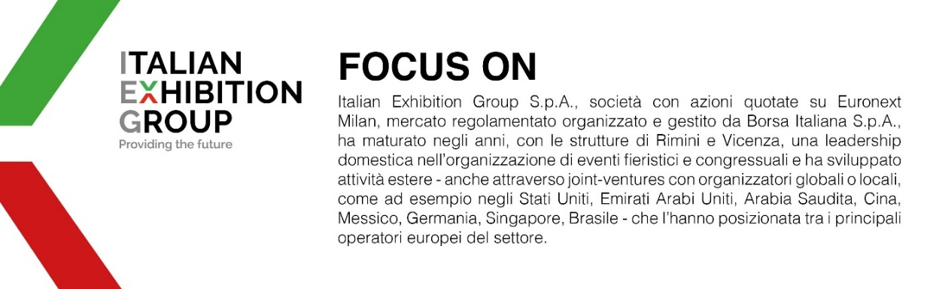
Il presente comunicato stampa contiene elementi previsionali e stime che riflettono le attuali opinioni del management (“forward- looking statements”) specie per quanto riguarda performance gestionali future, realizzazione di investimenti, andamento dei flussi di cassa ed evoluzione della struttura finanziaria. I forward-looking statements hanno per loro natura una componente di rischio e incertezza perché dipendono dal verificarsi di eventi futuri. I risultati effettivi potranno differire anche in misura significativa rispetto a quelli annunciati, in relazione a una pluralità di fattori tra cui, a solo titolo esemplificativo: andamento del mercato della ristorazione fuori casa e dei flussi turistici in Italia, andamento del mercato orafo - gioielliero, andamento del mercato della green economy; evoluzione del prezzo delle materie prime; condizioni macroeconomiche generali; fattori geopolitici ed evoluzioni del quadro normativo. Le informazioni contenute nel presente comunicato, inoltre, non pretendono di essere complete, né sono state verificate da terze parti indipendenti. Le proiezioni, le stime e gli obiettivi qui presentati si basano sulle informazioni a disposizione della Società alla data del presente comunicato.

