press release no. 5

SIGEP WORLD 2025, THE BIG NEW ENTRY: THE SUSTAINABILITY DISTRICT

- The 46th edition will have an area in Hall B1 entirely dedicated to sustainability with a focus on coffee and chocolate. The two supply chains are growing strongly: in 2024 they accounted for 21% of exhibitors and 18% of the almost 500 top buyers.

- Three ‘on site’ projects: Micro Roaster Village, Bean To Bar and Fully Automatic Coffee Machines. IEG's commitment to sustainability has also been implemented through cutting-edge technologies and new agreements.

- Italy’s top competitions to elect the winners who will take part in the World Coffee Events circuit’s competitions will be confirmed in the Coffee Arena.

Rimini, 20th December 2024 – One of the big new entries at SIGEP World 2025, organised by Italian Exhibition Group and scheduled to take place at Rimini Expo Centre from 18th to 22nd January 2025, is undoubtedly the large area dedicated to sustainability by means of a specific project: the Sustainability District. Located in Hall B1, it will promote virtuous practices applied to the coffee and cocoa supply chains. Thanks to collaboration with the Italian Trade Agency (ITA), together with AICS - the Italian Agency for Development Cooperation and IILA - the Italo Latin American Institute, the project will involve countries of origin, such as Ecuador, Costa Rica, El Salvador, Venezuela, Colombia, Ethiopia, Tanzania, Uganda, Ivory Coast and Kenya, offering a unique opportunity to promote the origins of coffee and cocoa and build ethical relationships along the supply chain.

THE THREE PROJECTS AND THE COMMITMENT TO SUSTAINABILITY

The Sustainability District will include 3 projects. Firstly, Micro Roaster Village, where micro-roasters will present their unique blends, revealing the latest trends in coffee sourcing, handling, roasting, preparation and distribution, as well as allowing visitors taste high quality coffee. Secondly, Bean To Bar, the area organised in collaboration with Guido Castagna, multi-award-winning Master Chocolate Roaster. Here, visitors will be able to immerse themselves in the world of technology and personally experience all the stages of artisan chocolate processing through workshops and guided tastings. Lastly, Fully Automatic Coffee Machines will be on show, a selection of super-automatic coffee machines that represent the future of the sector in the name of sustainability. With their smart energy management systems and waste reduction, they help minimise environmental impact.
Italian Exhibition Group's commitment to sustainability does not stop at the Sustainability District. In view of the 46th edition, the over 160,000 square metres of green area surrounding the Expo Centre has been further implemented to arrive at 1,500 plants and 30,000 square metres of lawns. Not forgetting the hall renovations and the relative air conditioning within the Centre, now achieved with an underground system that produces cold at night in order to return cool during the day, thus reducing the use of electricity by 50%.
Moreover, IEG has signed important agreements aimed at sustainable practices. Starting with Prostand, IEG's outfitting company, which has set out on a path towards sustainability by adopting eco-friendly solutions such as the use of recycled and certified materials, LED lighting and modular furnishings. Then IEG has adhered to the ‘Food for Good’ project against food waste that has allowed the company to ‘save’ over 30,000 meals since 2015. Progress also recognised by the prestigious ISO certifications for the environment, health and safety at work.

COFFEE ARENA

As far as the Arenas are concerned, SIGEP World 2025 will once again feature the Coffee Arena (Hall D1), where the Italian finals of the various specialities dedicated to the world of coffee will be staged in order to designate the winners who will represent their country around the world in the international competitions of the prestigious World Coffee Events circuit. There will also be talks and information sessions on the main coffee trends.
7 disciplines will be competing: Italian Barista Coffee Championship (CIBC); Italian Latte Art Championship (CILA); Italian Championship of Coffee in Good Spirits (CIGS); Italian Brewers Cup Championship; Italian Cup Tasters Championship; Italian Coffee Roasting Championship; Italian Cezve/Ibrik Championship.
The championships are organised in collaboration with Specialty Coffee Association Italy.

PRESS CONTACT SIGEP ITALIAN EXHIBITION GROUP
head of media relation & corporate communication: Elisabetta Vitali; press office manager: Marco Forcellini, Pier Francesco Bellini; press office coordinator: Luca Paganin; international press office coordinator: Silvia Giorgi; press office specialist: Nicoletta Evangelisti, Mirko Malgieri - media@iegexpo.it

MEDIA AGENCY SIGEP: Mind The Pop
Martina Vacca: martina@mindthepop.it, mob. +39 339 748 5994; Fabrizio Raimondi: fabrizio@mindthepop.it, mob. +39 335 389 848; Benedetto Colli: benedetto@mindthepop.it, mob. 380 371 2272; Stefano Chiossi: stefano@mindthepop.it, mob. + 39 388 739 4358.

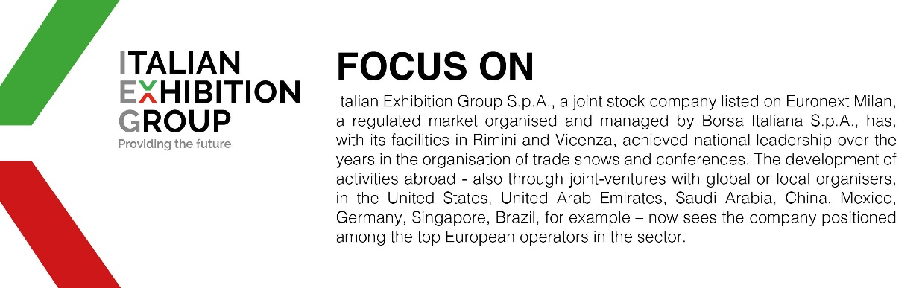

This press release contains forecast elements and estimates that reflect the management´s current opinions (´forward-looking statements´), particularly regarding future management performance, realization of investments, cash flow trends and the evolution of the financial structure. For their very nature, forward-looking statements have a component of risk and uncertainty, as they depend on the occurrence of future events. The effective results may differ (even significantly) from those announced, due to numerous factors, including, only by way of example: food service market and tourist flow trends in Italy, gold and jewellery market trends, green economy market trends; the evolution of raw material prices; general macroeconomic conditions; geopolitical factors and evolutions in the legislative framework. Moreover, the information contained in this release, does not claim to be complete, and has not been verified by independent third parties. Forecasts, estimates and objectives contained herein are based on the information available to the Company as at the date of this release.

