SIGEP MEETS THE WORLD:
CHICAGO OPENS SIGEP WORLD’S INTERNATIONAL CALENDAR
Networking cocktails, international relations and a global vision: an eight-stop tour across four continents for Italian Exhibition Group’s new roadshow format leading up to SIGEP World 2027. The tour officially kicks off next Monday, May 18, at Gene & Georgetti.
www.sigep.it
Chicago, May 13, 2026 – SIGEP Meets the World, the networking format created by Italian Exhibition Group to promote the vision of SIGEP World, officially launches in Chicago next Monday, May 18. SIGEP World is the leading international trade show dedicated to Gelato, Pastry, Bakery, Coffee, Chocolate and Pizza, and every January in Rimini it becomes the global meeting point where professionals do business, anticipate trends and shape the future of high-end Foodservice.
The upcoming tour introduces an enhanced format designed for the most dynamic Foodservice markets worldwide. Between now and November, the roadshow will stop in eight cities across four continents, combining business opportunities and networking in the major capitals of contemporary Ho.Re.Ca. Following the United States, the tour will continue in Brazil, Vietnam, Japan, Poland, Turkey, Germany and France.
Chicago marks the first stage of a format aimed at reinforcing SIGEP World’s global reach: a trade show ecosystem that, originating from the heart of Rimini, now extends its international leadership through the annual editions of SIGEP USA in Las Vegas and SIGEP Asia in Singapore, ensuring extensive coverage of the world’s leading premium Foodservice markets.
CHICAGO, FIRST NETWORKING STOP FOR SIGEP WORLD
The event will take place on May 18 at Gene & Georgetti, a historic name in American hospitality located in the heart of Chicago. The invitation-only networking cocktail event aims to bring together buyers, distributors and wholesalers, food & beverage importers, restaurant and coffee shop chains, manufacturers interested in the Italian market, as well as professionals specializing in Foodservice technologies and equipment.
THE PROGRAM
The evening will begin at 6 p.m. at the award-winning Tuscan-inspired venue on Franklin Street, in the heart of the North River district, with welcome remarks by Ilaria Cicero, Global Exhibition Director of IEG’s Food & Beverage Division. Buyers attending the event will also share their experience visiting SIGEP in Rimini and discuss the business and networking opportunities generated by the show. The event will continue with a convivial networking moment in a relaxed atmosphere designed to encourage exchange and dialogue among participants — a taste of Italian hospitality.
«With the Chicago event - comments Ilaria Cicero, Global Exhibition Director of IEG’s Food & Beverage Division - we are launching a long-term strategic journey that, over the coming months, will help strengthen an increasingly extensive network of relationships among companies, markets and cultures, while also creating new ones, building on SIGEP’s heritage of expertise, know-how and valuable partnerships».
Leading companies from SIGEP World’s key sectors — Gelato, Pastry, Bakery, Coffee, Chocolate and Pizza — will attend the event in Chicago, showcasing ingredients, technologies, equipment and new business models capable of connecting global demand with the innovative drive of Made in Italy.
The roadshow will accompany the international community toward SIGEP World 2027, scheduled to take place from January 23–27, 2027 at the Rimini Expo Centre, the world’s benchmark event for Foodservice excellence. The 2026 edition further confirmed the show’s international standing, attracting professionals from 160 countries, more than 500 top buyers from 75 nations, and recording significant growth in the participation of international companies, with exhibitors from 45 countries.
STRATEGIC PARTNERS
SIGEP Meets the World is organized by IEG in collaboration with the Italian American Chamber of Commerce Midwest, with the strategic support of ITA – Italian Trade Agency, as part of the international promotion program aimed at enhancing Italian Foodservice excellence across major global markets.
SIGEP WORLD 2026 IN FIGURES
138,000 sqm exhibition area
1,400 exhibiting brands (+8%) from 47 countries
198,000 attendees from 160 countries
502 Top Buyers from 75 countries with more than 5,800 business meetings
SIGEP NETWORK – SIGEP’s INTERNATIONAL TRADE SHOW EVENTS
SIGEP CHINA, Shanghai, June 17–18, 2026
SIGEP ASIA, Singapore, July 15–17, 2026
SIGEP WORLD, Rimini, Italy, January 23–27, 2027
SIGEP USA, Las Vegas, April 13–15, 2027

PRESS CONTACT ITALIAN EXHIBITION GROUP | media@iegexpo.it
head of corporate communication & media relation: Elisabetta Vitali|
press office manager: Marco Forcellini, Pier Francesco Bellini | international press office coordinator: Silvia Giorgi | press office coordinator: Luca Paganin | press office specialist: Nicoletta Evangelisti, Mirko Malgieri
MEDIA AGENCY SIGEP World: Mind The Pop
Martina Vacca: martina@mindthepop.it, mob. +39 339 748 5994; Fabrizio Raimondi: fabrizio@mindthepop.it, mob. +39 335 389 848; Benedetto Colli: benedetto@mindthepop.it, mob. 380 371 2272; Stefano Chiossi: stefano@mindthepop.it, mob. + 39 388 739 4358.

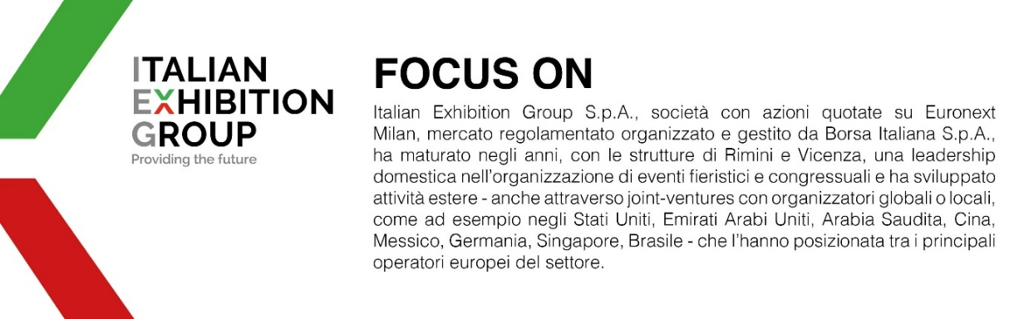
Il presente comunicato stampa contiene elementi previsionali e stime che riflettono le attuali opinioni del management (“forward- looking statements”) specie per quanto riguarda performance gestionali future, realizzazione di investimenti, andamento dei flussi di cassa ed evoluzione della struttura finanziaria. I forward-looking statements hanno per loro natura una componente di rischio e incertezza perché dipendono dal verificarsi di eventi futuri. I risultati effettivi potranno differire anche in misura significativa rispetto a quelli annunciati, in relazione a una pluralità di fattori tra cui, a solo titolo esemplificativo: andamento del mercato della ristorazione fuori casa e dei flussi turistici in Italia, andamento del mercato orafo - gioielliero, andamento del mercato della green economy; evoluzione del prezzo delle materie prime; condizioni macroeconomiche generali; fattori geopolitici ed evoluzioni del quadro normativo. Le informazioni contenute nel presente comunicato, inoltre, non pretendono di essere complete, né sono state verificate da terze parti indipendenti. Le proiezioni, le stime e gli obiettivi qui presentati si basano sulle informazioni a disposizione della Società alla data del presente comunicato.

