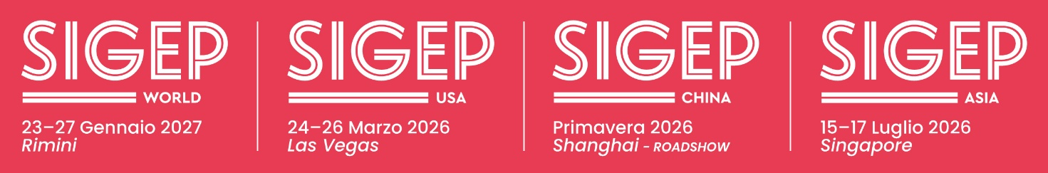

press release

IEG, SIGEP USA DEBUTS IN LAS VEGAS

• From tomorrow until March 26 at the Las Vegas Convention Center in conjunction with the International Pizza Expo (IPE) organized by Emerald
• Already present in China and Singapore, with its arrival in the USA, Italian Exhibition Group’s SIGEP World - the world expo for foodservice excellence, strengthens the global network for professional operators in the gelato, pastry & chocolate, coffee, bakery and pizza sectors

Rimini, 23rd March 2026 – Italian Exhibition Group (IEG) has launched another overseas initiative. After last January’s edition of SIGEP World at Rimini Expo Center – which, with 1,300 exhibiting brands and operators from 160 countries, confirmed the event’s role as an international Foodservice excellence hub - the leading event for the gelato, pastry & chocolate, coffee, bakery and pizza sectors is taking a further step in its global development. From tomorrow to March 26 at the Las Vegas Convention Center, SIGEP World will be making its debut on the US market with the first edition of SIGEP USA as part of the International Pizza Expo (IPE) organized by Emerald.

The Rimini edition highlighted a growth in internationalization, strengthening SIGEP World’s role as a global platform for top foodservice supply chains and companies amid innovation and new business models.

“With the US debut,” says IEG CEO, Corrado Peraboni, “Sigep's international network consolidates its presence in the most dynamic global foodservice markets. In 2026, we will also be holding SIGEP China with the roadshow scheduled for spring in Shanghai, and SIGEP Asia from 15 to 17 July in Singapore. The Las Vegas event completes a strategy that covers some of the most strategic areas for the sector’s global development.”

Ilaria Cicero, recently nominated as IEG’s global exhibition director, Food&Beverage Division, comments:
“SIGEP USA is an important step in the international development of the SIGEP brand. After the success of Rimini and the consolidation of the shows in Asia, our debut in the United States will allow us to build an increasingly integrated network between companies, professionals and markets, and consequently enhance the excellence of gelato, pastry, coffee and chocolate supply chains around the world".

THE U.S. MARKET AND THE POWER OF ITALIANNESS
The US market is one of the main drivers of global Foodservice as well as one of the most important areas for the diffusion of Italian gastronomic culture: the Italian restaurant sector is worth over 112 billion dollars, with 45,000 businesses involved, confirming the strong demand for products and formats linked to Italian cuisine (source: IBISWorld - Italian Restaurants Industry Report). In this scenario, the premium desserts segment inspired by Italian tradition is also growing. In 2024, the United States’ gelato market amounted to approximately $3.6 billion and could exceed $5 billion by 2033 supported by the growing demand for artisanal and authentic desserts linked to Italian food tradition (source: Grand View Research – U.S. Gelato Market Report). Consumer interest in premium, natural and high-quality products is, in fact, driving the growing popularity of artisanal gelato and its presence on Foodservice and catering menus (source: https://www.grandviewresearch.com/industry-analysis/us-gelato-market-report). A high-profit product and a tool that can expand the offer and increase margins.

STRATEGIC PARTNERSHIPS FOR PROMOTING ITALIAN EXCELLENCE
SIGEP USA has been organized in collaboration with ITA – Italian Trade Agency, a strategic partner in the international promotion of Italian companies and the enhancement of Made-in-Italy excellence around the world. Another strategic partnership involves Emerald, the organizer of the International Pizza Expo, the most important event for pizza in the United States. Hence, a dialogue between two internationally- renowned symbolic products of Italian cuisine - pizza and artisanal gelato - which will result in new business opportunities for the entire sector.

GELATO A KEY PLAYER ALSO IN THE UNITED STATES
The central role of gelato in the SIGEP world will be confirmed by the Gelato Festival World Masters Grand Finale, which will take place during the International Pizza Expo. This international competition features the world’s best gelato makers. SIGEP, together with Carpigiani, is a strategic partner in the project, which saw the conclusion of the international selections at SIGEP World in Rimini, where the Italian final took place.

PARTICIPATING COMPANIES AND THE DEBUT OF SIGEP CLUB
SIGEP USA will feature leading companies in the gelato, pastry, chocolate and coffee sectors, some of which will be joining the SIGEP Club for the first time, a recognition for brands that participate in multiple SIGEP network events around the world. The Club consists of an elite of companies that share an international vision and contribute to building value at all the Sigep brand’s venues.

PRESS CONTACT - ITALIAN EXHIBITION GROUP
head of media & corporate communication: Elisabetta Vitali; press office manager: Pier Francesco Bellini, Marco Forcellini; international press office coordinator: Silvia Giorgi; press office coordinator: Luca Paganin; press office specialist: Nicoletta Evangelisti, Mirko Malgieri; press office assistant: Julia Andreatta media@iegexpo.it

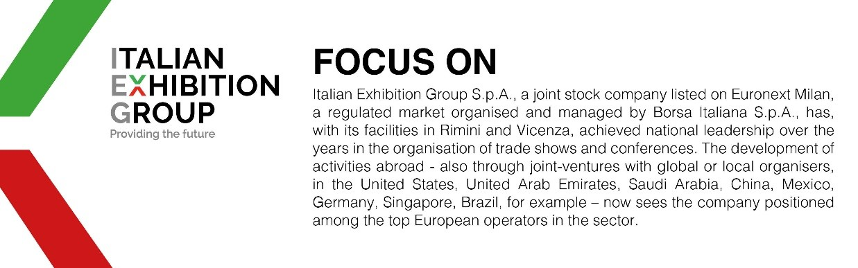
This press release contains forecast elements and estimates that reflect the management´s current opinions (´forward-looking statements´), particularly regarding future management performance, realization of investments, cash flow trends and the evolution of the financial structure. For their very nature, forward-looking statements have a component of risk and uncertainty, as they depend on the occurrence of future events. The effective results may differ (even significantly) from those announced, due to numerous factors, including, only by way of example: food service market and tourist flow trends in Italy, gold and jewellery market trends, green economy market trends; the evolution of raw material prices; general macroeconomic conditions; geopolitical factors and evolutions in the legislative framework. Moreover, the information contained in this release, does not claim to be complete, and has not been verified by independent third parties. Forecasts, estimates and objectives contained herein are based on the information available to the Company as at the date of this release.

