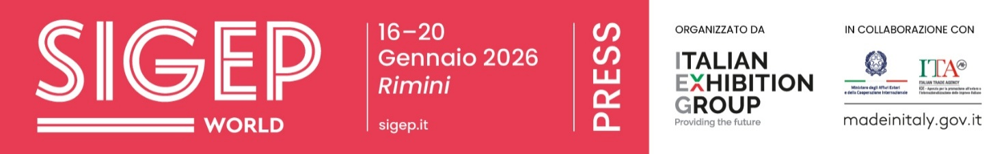

Press release
SIGEP WORLD KICKS OFF TOMORROW AT RIMINI EXPO CENTRE SHOWCASING THE BEST IN GLOBAL FOODSERVICE
- Present at the opening ceremony, Alessandra Locatelli, Minister for Disabilities, Michele de Pascale, President of the Emilia-Romagna Region, Lorenzo Galanti, Director General of the Italian Trade Agency, Juri Magrini, Councillor for Economic Activities of the Municipality of Rimini, and Maurizio Ermeti, President of Italian Exhibition Group.
- Italy’s Minister of Agriculture, Food Sovereignty and Forests, Francesco Lollobrigida, will attend the expo on Monday, 19 January.
sigep.it
PRESS NOTE - Press briefing on Friday 16th at 11:30 am, Vision Plaza – Cagnoni Dome – South Hall.

Rimini, 15 January 2026 —Starting tomorrow, and running for five days, Rimini Expo Centre will once again become the international hub for the foodservice industry, hosting the 47th edition of SIGEP World – The World Expo for Foodservice Excellence. Until Tuesday January 20, the Italian Exhibition Group event will bring together production, technology, and out-of-home markets under one roof.
The trade fair highlights the complex and interconnected supply chains of gelato, pastry, chocolate, coffee, bakery, and pizza, showcasing them as integral parts of a single, evolving ecosystem. International markets, cutting-edge technologies, and forward-looking growth models will be on display, reflecting the global trends shaping the industry. The scale of SIGEP World 2026 underscores its importance: over 1,300 exhibitors will participate, representing the best of Italian manufacturing, alongside a 33% increase in international exhibitors compared to last year. Buyers from 75 countries are expected in Rimini, with India featured as the Guest Country for 2026.
OPENING CEREMONY
The opening ceremony will take place at 12:00pm at Vision Plaza – Cagnoni Dome – South Hall. Speakers will include Alessandra Locatelli, Minister for Disabilities; Michele de Pascale, President of the Emilia-Romagna Region; Lorenzo Galanti, Director General of ICE Agency; Juri Magrini, Councillor for Economic Activities of the Municipality of Rimini; and Maurizio Renzo Ermeti, President of Italian Exhibition Group. Francesco Lollobrigida, Minister of Agriculture, Food Sovereignty, and Forestry, will be present at the fair on Monday, 19 January.
EXPLORING NEW DIRECTIONS IN GELATO, PIZZA, AND FOOD AS DRIVERS FOR HOSPITALITY
SIGEP World 2026 will focus on the key themes shaping the global foodservice industry. SIGEP Vision, the fair’s dedicated space for analysing international markets and trends, will serve as the central hub for industry dialogue. Ice cream is expanding beyond artisanal production, becoming a vehicle for shared professional culture and partnerships with hotel chains. Pizza is evolving with increasingly organised production structures. Bakery and pastry sectors are entering a phase of maturation, emphasizing raw material selection, process management, and high-quality production, from daily consumption to premium hospitality offerings. Coffee continues to innovate through sustainability, automation, and professional expertise. New strategic projects will also be featured, including Luxury Hotel Food Experience, exploring the role of food in high-end hospitality; the Sustainability District, focusing on product origin and supply chain responsibility; and Innovation Bar, a space to discuss the evolution of the contemporary bar.
START-UPS, AWARDS AND INTERNATIONAL INDUSTRY COMPETITIONS
SIGEP World 2026 also highlights innovation through the Lorenzo Cagnoni Innovation Award and the SIGEP Start-Up Award, alongside the participation of 20 international start-ups. Competitions remain a core feature of the fair, from the Gelato World Cup and Junior Pastry World Cup to Pizza Senza Frontiere – World Pizza Champion Games, alongside national competitions dedicated to coffee, gelato, and breadmaking.

GELATO, PIZZA, AND COFFEE DRIVE GROWTH: ITALIAN FOOD RESILIENT TO INFLATION AND STRONG IN EXPORTS
In 2025, the artisanal gelato sector recorded an overall sales growth of 8.5%, reaching €16.5 billion worldwide. Italy has consolidated its leadership, confirming its position as the world’s leading market with a turnover of €3.1 billion (up 3.5% compared to 2024, including ancillary products). (Sources: ACOMAG, Confartigianato, Confesercenti, FIPE-Confcommercio, ISTAT, Unione Italiana Food). This trend is also evident in the pastry sector, which has over 54,000 businesses operating in Italy. Turnover is growing by 4% to 5%, and premium demand is expanding, driven by celebratory pastries and international markets. (Sources: Confartigianato, Codacons, IRI, Unionfood, ICCO). The bakery sector is more mature but structurally sound, generating an estimated total turnover of €13.4 billion, with around €8.4 billion attributable to bread alone. Demand is shifting towards specialty breads, local flours, and higher value-added products (sources: Confartigianato Alimentare, Assopanificatori Confesercenti, AIBI, Italmopa). ​Pizza is a key player in this context, with around 2.7 billion pizzas produced annually and a total turnover exceeding 15 billion euros, confirming its position as a pillar of the Italian foodservice industry (sources: CNA Agroalimentare, Coldiretti, Movimprese, FIPE-Confcommercio). Completing the picture is coffee, which in 2024 generated a turnover of approximately €5.7 billion, with stable production and a recovery in exports worth over €2.6 billion. Italy remains the European leader in coffee roasting and professional coffee machines, a sector with an export share exceeding 70% (sources: Consorzio Promozione Caffè, UCIMAC, ISMEA, Comitato Italiano Caffè, ANIMA).

ITALIAN EXHIBITION GROUP PRESS CONTACTS | media@iegexpo.it
head of corporate communication & media relations: Elisabetta Vitali|
press office manager: Marco Forcellini, Pier Francesco Bellini | international press office coordinator: Silvia Giorgi | press office coordinator: Luca Paganin | press office specialist: Nicoletta Evangelisti, Mirko Malgieri
MEDIA AGENCY SIGEP World: Mind The Pop
Martina Vacca: martina@mindthepop.it, mob. +39 339 748 5994; Fabrizio Raimondi: fabrizio@mindthepop.it, mob. +39 335 389 848; Benedetto Colli: benedetto@mindthepop.it, mob. 380 371 2272; Stefano Chiossi: stefano@mindthepop.it, mob. + 39 388 739 4358.

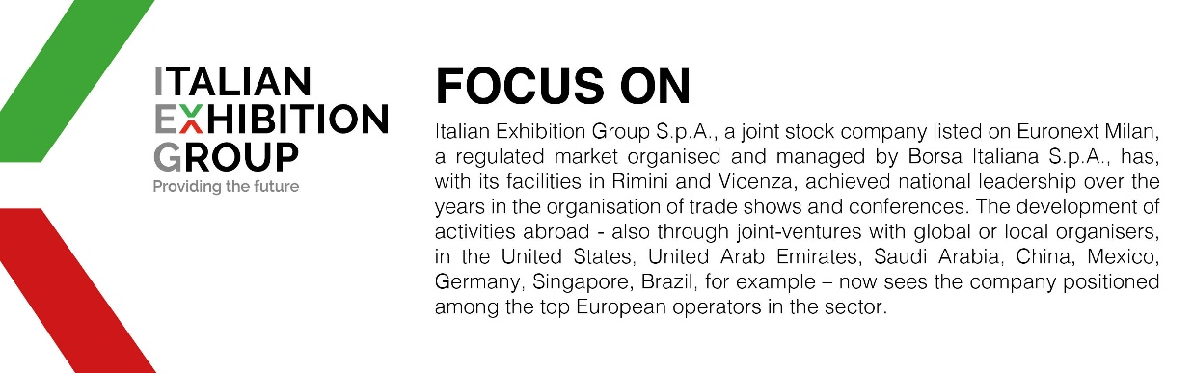

This press release contains forecast elements and estimates that reflect the management´s current opinions (´forward-looking statements´), particularly regarding future management performance, realization of investments, cash flow trends and the evolution of the financial structure. For their very nature, forward-looking statements have a component of risk and uncertainty, as they depend on the occurrence of future events. The effective results may differ (even significantly) from those announced, due to numerous factors, including, only by way of example: food service market and tourist flow trends in Italy, gold and jewellery market trends, green economy market trends; the evolution of raw material prices; general macroeconomic conditions; geopolitical factors and evolutions in the legislative framework. Moreover, the information contained in this release, doe not claim to be complete, and has not been verified by independent third parties. Forecasts, estimates and objectives contained herein are based on the information available to the Company as at the date of this release.

