Press release no. 11

SIGEP WORLD 2026 LAYOUT

Rimini, 22 December 2025 – The layout of SIGEP World (Rimini Expo Centre, Friday 16 – Tuesday 20 January 2026) reflects the event’s key sectors: gelato, pastry, chocolate, bakery, pizza, and coffee, spanning an impressive 138,000 m² of exhibition space. The design features clear, dynamic pathways leading to themed arenas and interactive areas, fostering discussion, networking, and new business opportunities.

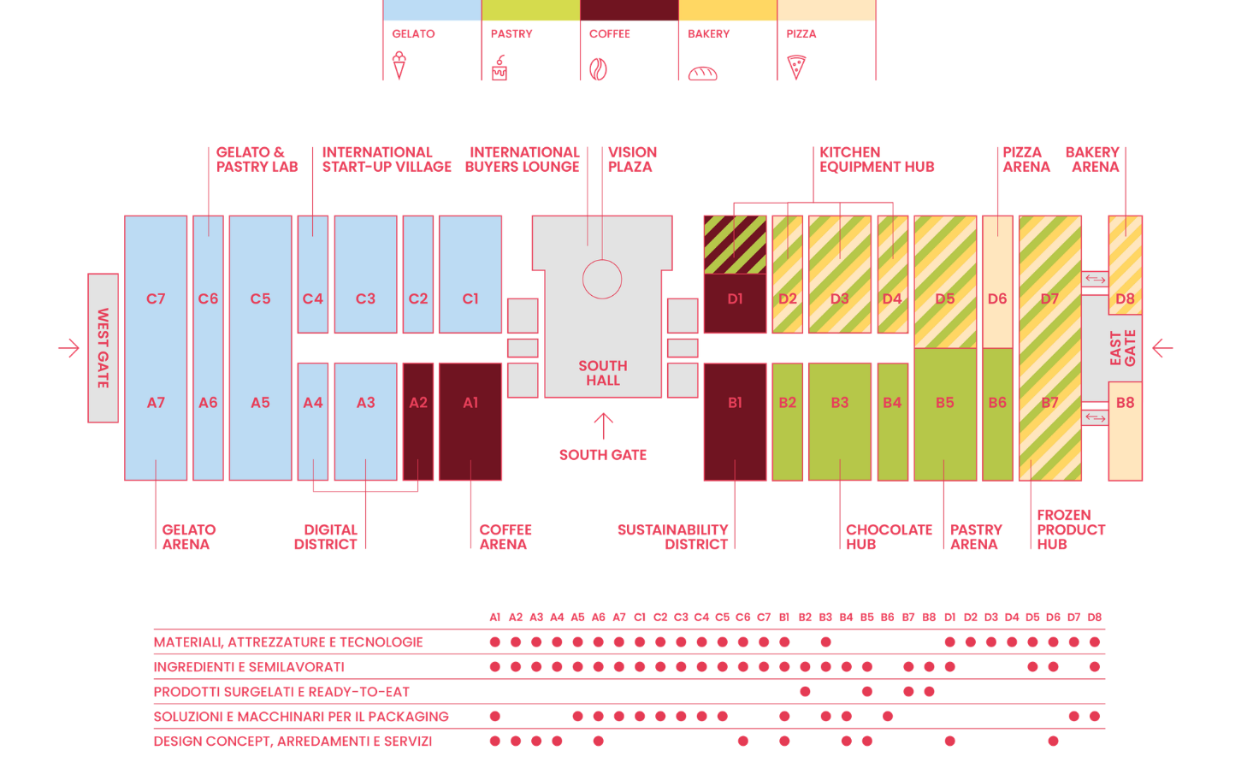

At the heart of the Italian Exhibition Group’s exhibition centre, in the South Hall, is Vision Plaza, the fair’s premier training venue. It hosts internationally renowned talks and panel discussions led by industry experts and opinion leaders, alongside the International Buyers Lounge.
The Rimini Fiera halls will showcase leading companies across the ingredients, products, technologies, furnishings, packaging, decorations, and services sectors for gelato, pastry, chocolate, coffee, bakery, and pizza.

Hall allocation is as follows:

- Gelato: 12 halls (A3–A7 and C1–C7)
- Coffee: 4 halls (A1, A2, B1, D1)
- Pastry & chocolate: 11 halls (D2–D7 and B7–B2)
- Bakery & pizza: halls D8 and B8 (opened last year with an additional 8,000 m²), with a dedicated focus on technology in D7 and pizza in D6

Among the new projects, the Kitchen Equipment Hub, located between D1 and D4, has been created in collaboration with ANIMA Confindustria and EFCEM Italia (part of APPLIA Italia), showcasing excellence in professional foodservice equipment. It features technologies for hot and cold applications, including washing systems, planetary mixers, steel tables, and utensils. The Frozen Product Hub, dedicated to innovative frozen ingredients and processing for bakery and pastry, will be in Hall B7, while the Digital District, located between A2 and A4, will highlight digital innovations driving growth in the Ho.re.ca sector.
Hall B1 will host the Sustainability District, promoting sustainable practices and offering an in-depth look at the coffee and cocoa supply chains, connecting conscious consumers with sustainable producers.
The Chocolate Hub in Hall B3 will feature leading international brands, showcasing the complete chocolate supply chain, from ingredients to processing technologies. Hall C4 will host the International Start-up Village, highlighting emerging innovations.

The Arenas

Gelato Arena (Hall A7): hosts the industry’s most important talks and major international competitions, including the Gelato World Cup.

Pastry Arena (Hall B5): dedicated to high-level pastry-making, including the Juniores Pastry World Cup, featuring 14 teams worldwide.

Pizza Arena (Hall D6): hosts Pizza Senza Frontiere: World Pizza Champion Games, with 17 categories celebrating Italy’s iconic dish.

Bakery Arena (Hall D8): showcases artisanal bread by international masters and introduces the National White Art Competition.

Coffee Arena (Hall A1): hosting the Italian finals of the Italian Barista and Coffee Championship (CIBC), the Italian Latte Art Championship (CILA), the Italian Coffee in Good Spirits Championship (CIGS), the Italian Brewers Cup Championship, the Italian Cup Tasters Championship, the Italian Coffee Roasting Championship, and the Italian Cezve/Ibrik Championship.

ITALIAN EXHIBITION GROUP PRESS CONTACTS| media@iegexpo.it
head of corporate communication & media relation: Elisabetta Vitali|
press office manager: Marco Forcellini, Pier Francesco Bellini | international press office coordinator: Silvia Giorgi | press office coordinator: Luca Paganin | press office specialist: Nicoletta Evangelisti, Mirko Malgieri
MEDIA AGENCY SIGEP World: Mind The Pop
Martina Vacca: martina@mindthepop.it, mob. +39 339 748 5994; Fabrizio Raimondi: fabrizio@mindthepop.it, mob. +39 335 389 848; Benedetto Colli: benedetto@mindthepop.it, mob. 380 371 2272; Stefano Chiossi: stefano@mindthepop.it, mob. + 39 388 739 4358.

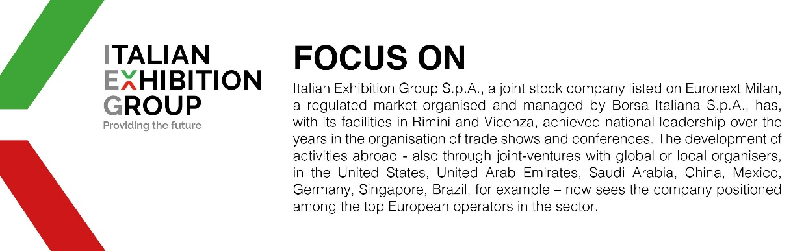

This press release contains forecast elements and estimates that reflect the management´s current opinions (´forward-looking statements´), particularly regarding future management performance, realization of investments, cash flow trends and the evolution of the financial structure. For their very nature, forward-looking statements have a component of risk and uncertainty, as they depend on the occurrence of future events. The effective results may differ (even significantly) from those announced, due to numerous factors, including, only by way of example: food service market and tourist flow trends in Italy, gold and jewellery market trends, green economy market trends; the evolution of raw material prices; general macroeconomic conditions; geopolitical factors and evolutions in the legislative framework. Moreover, the information contained in this release, doe not claim to be complete, and has not been verified by independent third parties. Forecasts, estimates and objectives contained herein are based on the information available to the Company as at the date of this release.

