Press release no. 10

SIGEP WORLD: DIRECT FLIGHTS FROM MUNICH AND MADRID, IN PARTNERSHIP WITH LUFTHANSA

- New direct flights to Rimini from Munich and Madrid, with discounted fares through the Lufthansa Group to support international growth.

- Agreement confirmed with Trenitalia for the ‘RiminiFiera’ stop on the Milan-Bari line with dedicated discounts, alongside bus and shuttle services, and arrangements for e-scooters and e-bikes.

sigep.it

Rimini, 22 December 2025 –SIGEP World, curated by Italian Exhibition Group, promises to be an extraordinary event, attracting exhibitors and visitors from all over the world. It will take place at the Rimini Expo Centre from Friday 16 to Tuesday 20 January 2026.
BY AIR
To support the growing international presence and facilitate access for buyers and exhibitors, new direct flights to Rimini have been introduced ​from Munich and Madrid.
Furthermore, SIGEP World 2026 has partnered with the Lufthansa Group (including Austrian Airlines, Brussels Airlines, Eurowings, Lufthansa, and SWISS) to offer discounted fares to Bologna Airport from over 310 destinations worldwide. ​Discounts are valid from one week before to one week after the event and can be booked through the dedicated portal.
From Rimini's 'Federico Fellini' airport, you can also reach the venue taking bus no.9, which stops at 'Via Emilia-Fiera'. ​A shuttle service is also available to and from Bologna Airport, with scheduled departures from ​16 to 20 January 2026 ​(prices and timetables can be obtained from the service providers). ​You can find all the information at this link.

BY TRAIN
The most direct way to reach the event is via the ​'RiminiFiera' station located within the trade fair venue. The station is served by both regional and long-distance trains on the Milan-Bari line, with direct stops.
Thanks to an ​agreement between the Italian Exhibition Group and Trenitalia, visitors can enjoy significant discounts on tickets: up to ​75% off Base fares on Frecciarossa, Frecciargento and Frecciabianca, and up to ​80% off Intercity and Intercity Night, across various service classes. Tickets can be purchased via the app, ticket offices, or the Trenitalia website. ​This offer applies to trips to or from Rimini or RiminiFiera, between two days before and one day after the event.
Rimini Central Station connects the city to the main high-speed, Intercity, and regional lines. During the event, visitors can take bus no. 9 and the shuttle bus line 9 to complete their journey to the fair entrances. ​Additionally, a special train will run between Santarcangelo di Romagna and Cattolica SGG, stopping at Rimini Fiera throughout the event.

BY CAR
Rimini Fiera is easily accessible via the A14 motorway. Exit at Rimini Nord and follow the signs to the exhibition centre. The venue offers ample parking, with both short-term and long-term options conveniently located near each entrance. The location is well-connected to major state roads, making it easy to reach from all directions. Rental car or taxi services are available from airports and stations, providing direct access to the South, East, and West entrances. Free shuttles connect these entrances and the East5 car park.
BUSES AND SHUTTLES
During the event, bus and shuttle services make it easy to travel between airports, the city, and the trade fair. Key options include buses no.5 and 10, which connect the northern and southern parts of Rimini, and bus no. 9 along with Shuttle line 9, providing regular service between Rimini station and the fair. A dedicated shuttle service runs several times a day between Bologna Airport and Rimini Fiera, with tickets available online or on board. Additional bus services from airports such as Forlì stop at the station or the South entrance, offering convenient transfer options. To further support attendees, IEG provides free special buses connecting the exhibition centre with major accommodation areas from Riccione to Bellaria (lines A-B-C-D).
METROMARE
The electrified Metromare line runs on a dedicated track between Rimini and Riccione, transporting thousands daily. Services operate every 15 minutes from early morning until evening, with a 23-minute journey including 15 stops. This ensures smooth travel for SIGEP World participants, operators, and visitors. Timetables are available at this link.

ITALIAN EXHIBITION GROUP PRESS CONTACTS | media@iegexpo.it
head of corporate communication & media relation: Elisabetta Vitali| press office manager: Marco Forcellini, Pier Francesco Bellini | international press office coordinator: Silvia Giorgi | press office coordinator: Luca Paganin | press office specialist: Nicoletta Evangelisti, Mirko Malgieri

MEDIA AGENCY SIGEP World: Mind The Pop
Martina Vacca: martina@mindthepop.it, mob. +39 339 748 5994; Fabrizio Raimondi: fabrizio@mindthepop.it, mob. +39 335 389 848; Benedetto Colli: benedetto@mindthepop.it, mob. 380 371 2272; Stefano Chiossi: stefano@mindthepop.it, mob. + 39 388 739 4358.

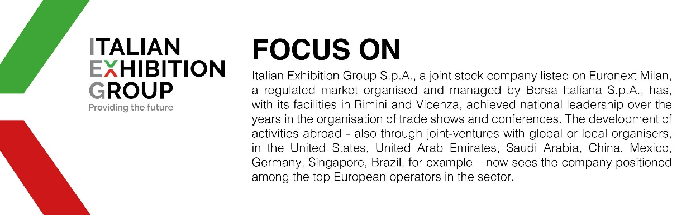

This press release contains forecast elements and estimates that reflect the management´s current opinions (´forward-looking statements´), particularly regarding future management performance, realization of investments, cash flow trends and the evolution of the financial structure. For their very nature, forward-looking statements have a component of risk and uncertainty, as they depend on the occurrence of future events. The effective results may differ (even significantly) from those announced, due to numerous factors, including, only by way of example: food service market and tourist flow trends in Italy, gold and jewellery market trends, green economy market trends; the evolution of raw material prices; general macroeconomic conditions; geopolitical factors and evolutions in the legislative framework. Moreover, the information contained in this release, doe not claim to be complete, and has not been verified by independent third parties. Forecasts, estimates and objectives contained herein are based on the information available to the Company as at the date of this release.

