Press release no. 7
SIGEP WORLD 2026:
TECHNOLOGY AND INNOVATION: KEY PLAYERS IN FOODSERVICE
- The 47th edition of the Italian Exhibition Group event, scheduled to take place at the Rimini Expo Centre from Friday 16 to Tuesday 20 January, will showcase the industry’s top innovations.
- Focus on three new projects: the Kitchen Equipment Hub, the Frozen Product Hub, and the Digital District, alongside the International Start-Up Village dedicated to the most innovative foodservice companies.
- The catering machinery market is valued at nearly €100 billion, with Italy being the fourth-largest producer globally. There is a growing trend towards technological solutions that are both environmentally friendly and incorporate Artificial Intelligence.
sigep.it
Rimini, 22 December 2025 – SIGEP World 2026 – The World Expo for Foodservice Excellence, an event curated by Italian Exhibition Group, will take place from Friday 16 to Tuesday 20 January at Rimini Expo Centre. The event will focus on technology as a key driver of development and innovation across all represented sectors: gelato, pastry, chocolate, coffee, bakery, and pizza. ​SIGEP World is an international hub for technological innovation in the foodservice industry. ​The event will focus on the latest technologies and innovative machinery, increasingly designed to reduce environmental impact, in response to global market challenges.
NEW SPECIAL PROJECTS FOCUSING ON TECHNOLOGY AND INNOVATION
The 47th edition of SIGEP World will feature three major new areas dedicated to technology: the Kitchen Equipment Hub, the Frozen Product Hub, and the Digital District.

- ​ KITCHEN EQUIPMENT HUB (hall ​D1 – D2 – D3 – D4)
The area dedicated to showcasing the excellence of professional foodservice equipment, developed in collaboration with ANIMA Confindustria and EFCEM Italia, a member of APPLIA Italia. Ovens, mixers, blast chillers, hobs, and new-generation technologies demonstrate how innovation, efficiency, and precision can improve daily work in kitchens, workshops, and bars, enhance product quality, and support the evolution of industry concepts.

- FROZEN PRODUCT HUB (Hall B7)
The space where bakery, pastry, and frozen technology converge. ​It showcases versatile, high-quality products designed for modern formats that demand efficiency, consistent results, and speed. ​An ally for those seeking solutions that combine craftsmanship, innovation, taste, and practicality, meeting the needs of an increasingly dynamic and international foodservice industry.

- DIGITAL DISTRICT (Halls A2-A3-A4)
An area dedicated to digital innovation for the foodservice industry. ​It brings together solutions that are growing exponentially: management software, online ordering platforms, marketing tools, payment systems, and data analytics. ​A hub demonstrating how digitalisation can optimise operations, enhance customer relationships, and accelerate the growth of out-of-home businesses.

Technology and innovation will be at the heart of the International Start-Up Village, a dedicated space spotlighting the most pioneering start-ups in the foodservice industry. Designed to foster collaboration, networking, and new business opportunities, the Village will showcase cutting-edge technologies, ingredients, equipment, digital solutions, and sustainable packaging across gelato, pastry, coffee, chocolate, bakery, and pizza industries. Created in partnership with the Italian Trade Agency and ANGI – the National Association of Young Innovators – the Village, located in Hall C4, offers a dynamic ecosystem aimed at accelerating the innovations that will shape the future of the global foodservice industry.

LE PARTNERSHIP DI UN SIGEP WORLD SEMPRE PIÙ RAFFORZATO
The 2026 programme brings together key industry stakeholders through strategic collaborations with leading associations and observatories. EFCEM Italia, the Association of Catering and Hospitality Equipment Manufacturers, will play a pivotal role in exploring the latest advancements in professional catering and hospitality technologies. Meanwhile, Assofoodtec – part of ANIMA | Confindustria Meccanica Varia, representing Italian manufacturers of machinery, plants, and equipment for the food industry – will spotlight innovations in the coffee sector through its UCIMAC (Union of Coffee Machine Manufacturers) section.
The programme will also feature key industry talks, including sessions organised by ANIMA:
- European regulations for food technologies: compliance for PFAS & Chemicals (Sustainability District/Friday 16 January, 4.00-5.00pm): This conference, in partnership with the Icim Group, will be an important opportunity for all companies producing technologies and operating in the food sector to discuss PFAS & Chemicals. The workshop is aimed at companies interested in understanding how to navigate a constantly evolving regulatory landscape, including legislative updates and compliance, in a context where product safety is a fundamental requirement for protecting human health. ​
- CEI EN 50730:2025-05, the new European standard for coffee machines (Cupola Cagnoni, Hall Sud, Saturday 17 January, 1:00-2:00pm). Published in April 2025, thanks to the work of UCIMAC – the Association of Manufacturers of Professional and Semi-Professional Coffee Machines and Equipment, federated with Anima Confindustria – the CEI EN 50730:2025-05 standard sets out clear criteria for measuring the energy consumption and productivity of professional coffee machines. By introducing uniform measurement methods for the energy consumption and productivity of professional and commercial coffee machines for the first time, the standard represents a significant step towards greater market transparency, benefiting the entire supply chain. This will allow the industry to rely on objective assessment tools to guide their purchasing and investment decisions.
MARKET DATA ON TECHNOLOGIES
According to EFCEM Italia, global demand for professional kitchen equipment surpassed €100 billion in 2024, up 8% from 2023. The market has quadrupled in less than two decades, growing from just over €25 billion in 2005. Production is concentrated in four countries—China, Germany, the United States, and Italy—which together account for roughly 50% of global output.
Italy remains the world’s fourth-largest producer, renowned for its culinary tradition, technological expertise, and innovation—a reputation further enhanced by UNESCO’s recent recognition of Italian Cuisine. In Europe, an analysis by Studia.BO of over 350 companies shows an average return on equity (ROE) of 13.5% and return on investment (ROI) of 14.3%. Italian manufacturers perform in line with the European average, delivering the sector’s highest EBITDA at 11.6%, though still slightly below German levels.
The product landscape is expanding to include multifunctional equipment, with ovens and blast chillers leading the way, alongside innovations in vacuum cooking, dynamic preparation, and pressure braising. Air treatment and air conditioning remain central, with a focus on energy efficiency and kitchen microclimates. Artificial intelligence is increasingly shaping catering processes, from customer service to operational management. These technological advancements are redefining required skills, making training a strategic priority for the industry.

ITALIAN EXHIBITION GROUP PRESS CONTACTS | media@iegexpo.it
head of corporate communication & media relation: Elisabetta Vitali| press office manager: Marco Forcellini, Pier Francesco Bellini | international press office coordinator: Silvia Giorgi | press office coordinator: Luca Paganin | press office specialist: Nicoletta Evangelisti, Mirko Malgieri
MEDIA AGENCY SIGEP World: Mind The Pop
Martina Vacca: martina@mindthepop.it, mob. +39 339 748 5994; Fabrizio Raimondi: fabrizio@mindthepop.it, mob. +39 335 389 848; Benedetto Colli: benedetto@mindthepop.it, mob. 380 371 2272; Stefano Chiossi: stefano@mindthepop.it, mob. + 39 388 739 4358.

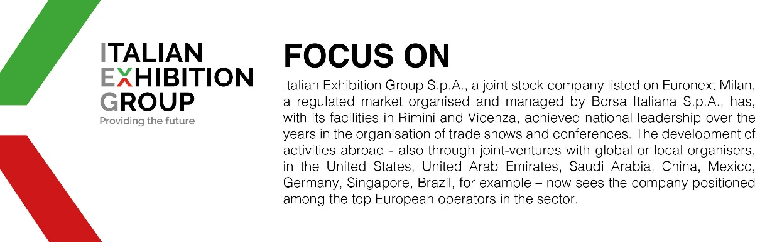

This press release contains forecast elements and estimates that reflect the management´s current opinions (´forward-looking statements´), particularly regarding future management performance, realization of investments, cash flow trends and the evolution of the financial structure. For their very nature, forward-looking statements have a component of risk and uncertainty, as they depend on the occurrence of future events. The effective results may differ (even significantly) from those announced, due to numerous factors, including, only by way of example: food service market and tourist flow trends in Italy, gold and jewellery market trends, green economy market trends; the evolution of raw material prices; general macroeconomic conditions; geopolitical factors and evolutions in the legislative framework. Moreover, the information contained in this release, doe not claim to be complete, and has not been verified by independent third parties. Forecasts, estimates and objectives contained herein are based on the information available to the Company as at the date of this release.

