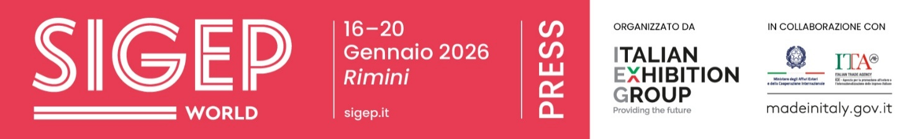

Press release no. 3
FROM HOTEL DINING EXPERIENCES TO BARS OF THE FUTURE:
SIGEP WORLD SPECIAL PROJECTS

- Luxury Hotel Food Experience highlights food as a strategic business driver for high-end hospitality, focusing on breakfast, catering, and experiential dining as value-added assets for hotels and international chains.

- Sustainability District and Innovation Bar explore supply chains and operational models: 21 African cooperatives and cocoa- and coffee-producing countries are featured, with contributions from ICE, IILA, the European Coffee Federation, the Specialty Coffee Association, and Circana. The bar industry explores the impact of super-automatic machines, artificial intelligence, and emerging technologies on operations and customer experience.

- Pizza (R)evolution and Gelato Meets Chains showcase the evolution of two iconic Italian products.

sigep.it
Rimini, 23 December 2025 — At SIGEP World (Rimini Expo Centre, 16–20 January 2026), the foodservice industry takes centre stage through a series of special projects and thematic platforms connecting products, supply chains, and business models. Luxury Hotel Food Experience, Sustainability District, Innovation Bar, Gelato Meets Chains, and Pizza (R)evolution are the platforms through which the Italian Exhibition Group (IEG) event explores ongoing transformations: from the role of food in premium hospitality to the evolving dynamics of bars, from sustainable supply chains to the strategies of international chains.

LUXURY HOTEL FOOD EXPERIENCE: FOOD AS THE LANGUAGE OF PREMIUM HOSPITALITY
In high-end hospitality, food and beverage have become decisive competitive levers. With Luxury Hotel Food Experience, SIGEP World 2026 presents case studies and discussion forums showing how breakfast, catering, and events shape the identity and positioning of luxury hotels—both independent and chain-affiliated.
Key events include “Signature breakfasts in luxury hospitality: the Portrait Milano case” (Pastry Arena – Hall B5), exploring one of the industry’s most significant trends through Portrait Milano, winner of Best Breakfast at the Best Luxury Hotel Awards 2024. Pastry Arena will be transformed into an immersive buffet inspired by the hotel’s breakfast, curated by Cesare Murzilli, Executive Pastry Chef at Portrait Milano. The event is open to buyers, companies, influencers, and trade media and features talks on luxury service, buffet presentation, and the role of water in pastry-making.

Drawing on the case history of Portrait Milano, which demonstrates how food can become a key element of identity and a positioning lever in high-end hospitality, the theme will be explored further at Vision Plaza with “Luxury Hotel Food Experience – restaurant offerings as a new competitive lever in positioning strategies” (17 January, 3 pm). This event will broaden the discussion on the role of food and wine, from breakfast to events, in the communication and value creation strategies of international hospitality.

Additional thematic sessions in Vision Plaza include:

- Food & Beverage as a positioning lever for the hotel industry (17 Jan, 12:00 pm): how restaurant offerings influence brand identity, pricing, and perception, becoming a decisive tool for differentiation in the global market.

- From cost centre to revenue engine (18 Jan, 12:00 pm): case studies showing how catering can generate 30–40% of total revenue, with peaks of 50%, thanks to integrated service management, storytelling, and organisation.

- Pastry, bakery and breakfast: new strategic assets for luxury brands (Monday, 19 January, 12:00): From breakfast to brunch, patisserie and bakery services are becoming essential for high-end establishments, serving as positioning levers and new revenue streams, including through opening to non-guests.

The conference “The hotel: the new potential market for the food world” (18 January, 3:30 pm), organised by POLI.design – Politecnico di Milano, completes the picture. It presents the results of the Observatory on breakfast and catering in hotels, offering a structured analysis of a rapidly growing channel whose operational and business dynamics are still little understood.

SUSTAINABILITY DISTRICT: SUPPLY CHAINS, ORIGINS, AND NEW MARKET RESPONSIBILITIES
Sustainability is becoming a key component of supply chain strategies. ​The Sustainability District at SIGEP World 2026 is once again a dedicated space for international dialogue, offering in-depth insights into the cocoa and coffee supply chains. It also showcases new technological solutions and case studies from the food industry, connecting producers, cooperatives, institutions, and companies across the entire value chain.
The project actively involves the Italian Trade Agency, IILA – the Italian-Latin American Institute, the European Coffee Federation, IICCT – the International Institute of Chocolate and Cacao Tasting, ​ ANIMA Confindustria, and universities such as BBS Bologna Business School and H-FARM. Together, they bring the voices of the countries of origin and production regions to the fair, alongside innovations, new technological opportunities related to energy sustainability, and new frontiers in the food industry.
Twenty-one cooperatives from six African countries – Uganda, Rwanda, Ethiopia, Côte d’Ivoire, Tanzania, and Kenya – will be present, alongside Latin American organisations from Costa Rica, Guatemala, and the Dominican Republic. The aim is to promote fairer, more transparent, and market-oriented cooperation models.
Within the district, visitors will find Chocolate Origins and the Bean to Bar route, curated by Maestro Guido Castagna, which details the transformation of cocoa from bean to bar. There is also the Choco Village, dedicated to the craft of chocolate making. ​The 2026 edition will also feature tea culture, representing a new frontier in the premium segment.

The programme features a comprehensive line-up of talks. ​Among the key events, the panel “Sustainability: a balancing act”, organised by the European Coffee Federation, will address the delicate balance between economic, social and environmental sustainability in the coffee industry. It will also examine the regulatory and market challenges faced by a global supply chain that accounts for around 35% of the world’s coffee trade.
IILA will also make a significant contribution, hosting a series of talks in the Sustainability District dedicated to Latin American coffee and cocoa producing countries, strengthening the link between origin, quality, and international business opportunities. ​The programme features expert insights from Comunicaffè, including the talk “Will super-automatic machines replace baristas?”, which addresses one of the most debated topics in the industry: the evolution of intelligent machines, their use in international markets, and the growing role of automation in high-traffic environments, without losing sight of the human and professional value of the barista. ​The programme is completed by initiatives from Gambero Rosso, including the Guida del Camaleonte, which showcases a tour of Italian cafés and roasteries, as well as contributions from the US association Women in Restaurants.

INNOVATION BAR: TECHNOLOGY, PEOPLE AND THE FUTURE OF COFFEE
The future of the bar industry hinges on the relationship between technology and expertise. Innovation Bar is SIGEP World’s concept area, showcasing espresso machines, super-automatics, artificial intelligence, and new plant-based solutions. It explores how the professional beverage industry is evolving amid automation, staff shortages, and changing consumer expectations.
The Innovation Bar project complements the Micro Roaster Village, a dedicated space for Italian and international micro-roasters. Here, coffee becomes a sensory experience, a story of origin, and a business opportunity, highlighting specialty coffees, new brewing methods, and direct relationships with producers.

GELATO: A STRATEGIC LEVER FOR GLOBAL FOODSERVICE
At SIGEP World 2026, gelato is evolving from a symbol of Italian craftsmanship into a strategic asset for the international foodservice industry, capable of generating profit, differentiation, and growth across various markets and formats. ​With Gelato Meets Chains, the event is developing a project aimed at international restaurant, hotel, coffee shop and bakery chains. It is designed to promote the integration of artisanal, soft and frozen gelato into global menus through targeted content, matchmaking and networking between companies and decision-makers. ​The international campaign “What is Gelato?” reinforces this vision, showcasing the identity and value of Italian gelato to a global audience of professionals and investors, culminating at SIGEP World. ​The guide “Gelato means Business”, produced for SIGEP World by Italian Exhibition Group in collaboration with ACOMAG, also fits into this context. It provides data, models, and case studies to demonstrate how ice cream can ensure high margins, seasonal consumption, and a rapid return on investment, adapting to any food service format.

PIZZA (R)EVOLUTION: COMPETENZE, VISIONE E NUOVI MERCATI
Following its debut in 2025, Pizza is entering a new phase with Pizza (R)evolution, a project that showcases not only an iconic product but also a genuine industrial and business platform. ​The fair presents a comprehensive vision, connecting ingredients and flours, production technologies, ovens and equipment, ready-to-use solutions, and service formats designed for independent pizzerias, structured groups, and international chains. ​Alongside the exhibition area, the event will feature a structured programme of talks and masterclasses, developed with contributions from ALMA – the International School of Italian Cuisine, a leading provider of high-quality training, key industry associations such as AVPN – the True Neapolitan Pizza Association and NIP – the Italian National Pizza Makers Association, and specialist media including 50 Top Pizzas, Italian Gourmet and FOOD Ristorazione Italiana Magazine.

ITALIAN EXHIBITION GROUP PRESS CONTACTS | media@iegexpo.it
head of corporate communication & media relation: Elisabetta Vitali|
press office manager: Marco Forcellini, Pier Francesco Bellini | international press office coordinator: Silvia Giorgi | press office coordinator: Luca Paganin | press office specialist: Nicoletta Evangelisti, Mirko Malgieri
MEDIA AGENCY SIGEP World: Mind The Pop
Martina Vacca: martina@mindthepop.it, mob. +39 339 748 5994; Fabrizio Raimondi: fabrizio@mindthepop.it, mob. +39 335 389 848; Benedetto Colli: benedetto@mindthepop.it, mob. 380 371 2272; Stefano Chiossi: stefano@mindthepop.it, mob. + 39 388 739 4358.

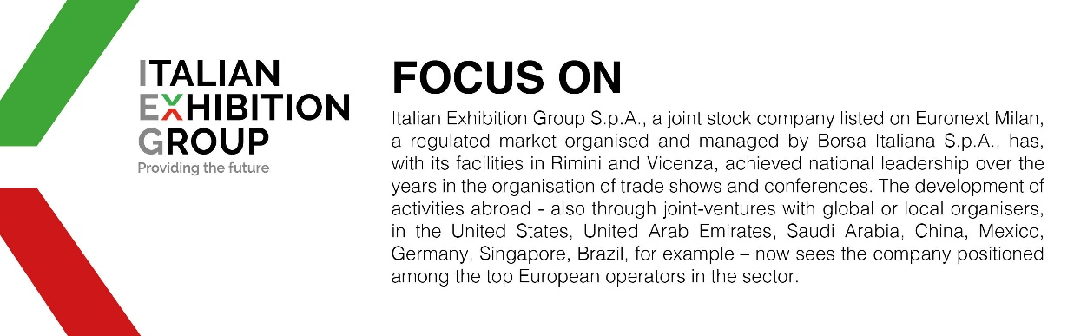

This press release contains forecast elements and estimates that reflect the management´s current opinions (´forward-looking statements´), particularly regarding future management performance, realization of investments, cash flow trends and the evolution of the financial structure. For their very nature, forward-looking statements have a component of risk and uncertainty, as they depend on the occurrence of future events. The effective results may differ (even significantly) from those announced, due to numerous factors, including, only by way of example: food service market and tourist flow trends in Italy, gold and jewellery market trends, green economy market trends; the evolution of raw material prices; general macroeconomic conditions; geopolitical factors and evolutions in the legislative framework. Moreover, the information contained in this release, doe not claim to be complete, and has not been verified by independent third parties. Forecasts, estimates and objectives contained herein are based on the information available to the Company as at the date of this release.

