Press release no. 6

TECHNOLOGICAL INNOVATIONS AND MARKET TRENDS: SIGEP VISION 2026 – SHAPING THE FUTURE OF FOODSERVICE

- Great anticipation for the talk on global trends and future scenarios in the gelato and foodservice industry, which will be discussed at Vision Plaza, focusing strongly on innovation, technology, and sustainability.

- Three important on-site projects confirmed: the International Start-Up Village, the Lorenzo Cagnoni Award, and the Sustainability District, showcasing the future and key initiatives shaping the industry.

Rimini, 22 December 2025 - A key reference point for the main market trends in the foodservice industry—and equally for the technological and sustainable innovations that will drive its future—SIGEP Vision is the flagship initiative of the 47th edition of SIGEP World, taking place at the Rimini Expo Centre from Friday 16 to Tuesday 20 January 2026, curated by Italian Exhibition Group.
Through a rich programme of initiatives that integrate ideas with physical spaces, SIGEP Vision offers a privileged perspective on industry trends. Thanks to collaborations with leading research institutes, stakeholders, and industry associations, it serves as a global observatory for the out-of-home industry, providing up-to-date trends and data throughout the year. In this way, SIGEP World confirms its position as the reference point for knowledge, innovation, and technology in the industry.

VISION PLAZA: THE HUB FOR KEY INDUSTRY TALKS
Located in the South Hall, VISION PLAZA will be the central stage for SIGEP VISION, hosting a full programme of panels, talks, and training sessions led by top experts and opinion leaders. The focus areas include market trends, technological innovations—particularly in the field of artificial intelligence—and sustainability, with a special emphasis on eco-friendly materials, waste reduction, and ethical sourcing.

Featured key sessions:

- SIGEP Vision talk (Friday 16 January, 2:30–3:15pm, Cupola Cagnoni, South Hall: Launching the programme after the Opening Ceremony, this highly anticipated talk explores strategic themes for the industry’s future, from new consumer habits and market-driven transformations to sustainability and digitalisation. A unique opportunity for professionals and companies to engage with international experts and leaders, anticipating the trends that will shape 2026.

- European regulations for food technologies: compliance for PFAS & Chemicals (Sustainability District/Friday 16 January, 4:00-5:00pm): The conference organised by ANIMA ​- Confindustria Meccanica Varia, in partnership with Icim Group, will be a key opportunity for all technology and food sector manufacturers to discuss PFAS & Chemicals. The workshop is aimed at companies interested in understanding how to navigate a constantly evolving regulatory landscape, including legislative updates and compliance, in a context where product safety is a fundamental requirement for protecting human health.

- The European restaurant market. ​Opportunities and future prospects (Cupola Cagnoni, Hall Sud/Saturday 17 January 2:00-2:30pm): The European foodservice market in 2025 is characterised by a delicate balance between challenges and opportunities. ​While economic pressures and changing consumer habits present challenges, they also drive innovation and adaptation. Jochen Pinsker, Industry Advisor for Foodservice Europe at Circana, will discuss the key trends shaping the European foodservice industry, supported by Circana data.

- The current state of out-of-home consumption in Italy. ​Opportunities and future prospects (Cupola Cagnoni, Hall Sud/Sunday 18 January 11-11:30): How did out-of-home consumption in Italy perform in 2025, and what are the prospects for the future? Matteo Figura, Executive Director of Foodservice at Circana, will discuss consumer trends and behaviours, identifying opportunities for growth and development for those working in this industry.

- Will super-automatic machines replace baristas? (Sustainability District, Hall B1/Sunday 18 January 11:00-12:15): This is not a straightforward question for the talk organised by Comunicaffè. Today’s machines are increasingly sophisticated, and in the most advanced models, artificial intelligence controls their mechanisms and regulates dispensing. ​The result is an impeccable cup quality, so much so that super-automatic machines pose a daily challenge for baristas. ​And what about traditional bars? ​Many cafés abroad prominently display super-automatic machines, but this is much less common in Italy. ​But this is just the beginning: the increasing difficulty in finding staff could be the real turning point.

- The confectionery supply chain and evolving consumer needs (Cupola Cagnoni, Hall Sud/Monday 19 January 1:00-1:45pm): Health, sustainability, and ethical choices are now key factors influencing consumer preferences, including in the food industry. ​The talk, organised by FIPE (the Italian Federation of Public Establishments), will bring together professionals and companies from the confectionery sector to outline a catering model that combines well-being, taste, and values, ensuring every customer has a safe, authentic, and accessible experience.

- The consumer has changed. ​And the baker? (Cupola Cagnoni, South Hall/Monday 19 January 11:00-11:30): This talk, organised by AIBI (the Italian Bakery Ingredients Association), which represents bread, pizza and pastry ingredient companies within ASSITOL, will present a review of Cerved’s research on the bakery and baked goods market. ​The survey explores the evolution of the art of baking and outlines the main consumer trends in Italy, focusing on the role of the baker.

ON-SITE PROJECTS
In addition to the keynote talks, SIGEP Vision will guide three on-site projects: the International Start-Up Village, the Lorenzo Cagnoni Award, and the Sustainability District.
The International Start-Up Village (Hall C4) is a dedicated physical and digital space for the most innovative start-ups in the foodservice industry, designed to foster meetings, networking, and the development of new business opportunities. ​Selected companies will be able to showcase technologies, ingredients, machinery, digital solutions, and sustainable packaging in the gelato, pastry, chocolate, coffee, bakery, and pizza sectors. ​The project, organised by IEG in collaboration with ICE-Agenzia and ANGI, welcomes both innovative Italian start-ups registered with the business register and international start-ups, assessing their coherence and innovative potential.
Within the focus on innovation, the 'Lorenzo Cagnoni Award' will be reintroduced. This award, dedicated to the former president of the Italian Exhibition Group – a key figure in the fair’s development and the internationalisation of the industry – celebrates the most innovative start-ups and products shaping the future of foodservice. ​The competition covers seven distinct areas: organic and free-from products; digital innovation and artificial intelligence solutions; technologies, equipment, and materials for professional kitchens; frozen and ready-made products; ingredients and semi-finished products; packaging solutions and related machinery; and projects promoting advanced sustainability models. ​Winners of the previous edition can be found at this link.
The Sustainability District (Hall B1) returns to SIGEP World 2026 for its second edition, serving as a hub dedicated to environmental and social sustainability, the origins of supply chains, and international cooperation, with a specific focus on the coffee and chocolate supply chains. ​The area comprises five main sections: Africa (ICE), Latin America (IILA), Chocolate Origins (IICCT), Bean to Bar, and the Talk Area.
The Africa section features producers and cooperatives from six countries – Côte d’Ivoire, Ethiopia, Kenya, Rwanda, Tanzania, and Uganda – while the Latin America area brings together Costa Rica, Guatemala, and the Dominican Republic. ​Chocolate Origins offers tastings and insights into the origins of cocoa, while the Bean to Bar experience, curated by Guido Castagna, showcases every stage of cocoa processing. ​The area also highlights the importance of traceability and the social value of supply chains, with the involvement of international institutions and organisations dedicated to sustainable development.
Project partners include Comunicaffè, Circana, IILA, the European Coffee Federation, Gambero Rosso, and the Specialty Coffee Association.

PRESS CONTACT ITALIAN EXHIBITION GROUP | media@iegexpo.it
head of corporate communication & media relation: Elisabetta Vitali| press office manager: Marco Forcellini, Pier Francesco Bellini | international press office coordinator: Silvia Giorgi | press office coordinator: Luca Paganin | press office specialist: Nicoletta Evangelisti, Mirko Malgieri
MEDIA AGENCY SIGEP World: Mind The Pop
Martina Vacca: martina@mindthepop.it, mob. +39 339 748 5994; Fabrizio Raimondi: fabrizio@mindthepop.it, mob. +39 335 389 848; Benedetto Colli: benedetto@mindthepop.it, mob. 380 371 2272; Stefano Chiossi: stefano@mindthepop.it, mob. + 39 388 739 4358.

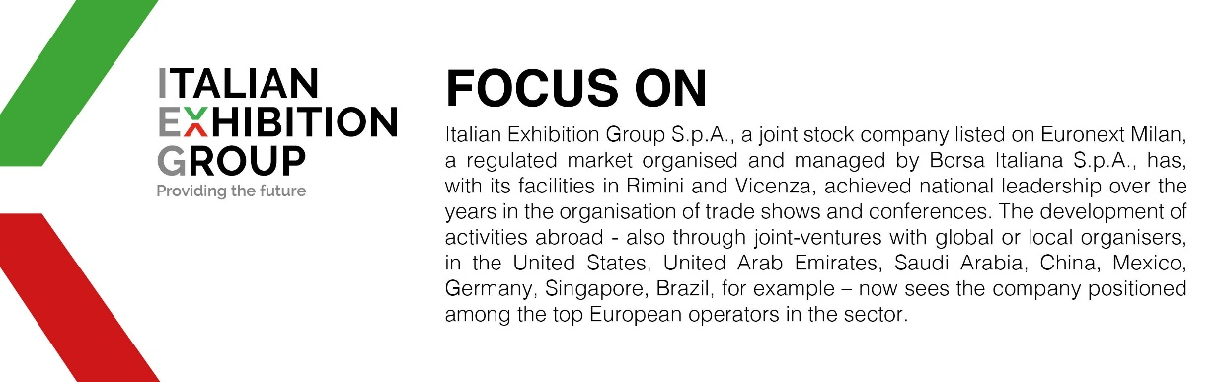

This press release contains forecast elements and estimates that reflect the management´s current opinions (´forward-looking statements´), particularly regarding future management performance, realization of investments, cash flow trends and the evolution of the financial structure. For their very nature, forward-looking statements have a component of risk and uncertainty, as they depend on the occurrence of future events. The effective results may differ (even significantly) from those announced, due to numerous factors, including, only by way of example: food service market and tourist flow trends in Italy, gold and jewellery market trends, green economy market trends; the evolution of raw material prices; general macroeconomic conditions; geopolitical factors and evolutions in the legislative framework. Moreover, the information contained in this release, doe not claim to be complete, and has not been verified by independent third parties. Forecasts, estimates and objectives contained herein are based on the information available to the Company as at the date of this release.

