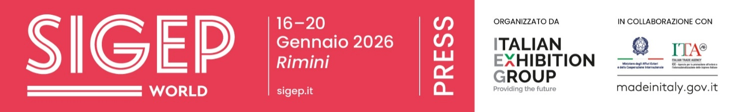

Press release no. 4
PASTRY & CHOCOLATE: HERITAGE, MARKET DYNAMICS AND EMERGING RESPONSIBILITIES

- From the Pastry Arena to the Sustainability District, SIGEP World 2026 (Italian Exhibition Group, Rimini Expo Centre, 16–20 January) brings together technology, supply chains and market innovation, showcasing award-winning desserts, signature breakfasts, and forward-looking entrepreneurial visions for the pastry industry.

- Cocoa from origin to final product: African and Latin American cooperatives, in collaboration with ICE Agency and IILA, will highlight bean-to-bar production and offer tastings in the International Institute of Chocolate and Cacao Tasting (IICCT) area.

- The Juniores Pastry World Cup (18–20 January) and the Italian Final of the Panettone World Cup (18 January) will select top talent ahead of the 2026 Panettone World Championship.

sigep.it
Rimini, 22 December 2025 — From Friday 16 to Tuesday 20 January 2026, at Rimini Expo Centre, SIGEP World – The World Expo for Foodservice Excellence, curated by Italian Exhibition Group (IEG), will shine a spotlight on Pastry and Chocolate, connecting technique, supply chains and market opportunities.
At the trade fair, pastry is presented as an evolving professional language, while chocolate is explored across the full value chain — from cocoa production to artisanal and industrial processing — highlighting both its complexity and business potential.

PASTRY: TECHNIQUES, FORMATS AND KEY EVENTS
The pastry sector bridges haute cuisine, luxury hotels, and new commercial opportunities. The Pastry Arena (Hall B5) will host talks and masterclasses with leading experts, blending technical insights with entrepreneurial vision.
Highlights include: “From Panettone to Starred Desserts: A Story of Sharing” (16 January, 11 am) – Kabir Godi and Pierfederico Pascale from the Cannavacciuolo world explore the connection between traditional panettone and contemporary haute pastry.
“The Pastry Consultant: An Entrepreneurial Choice” (16 January, 1 pm) – in collaboration with AMPI, this session examines consultancy as a tool for professional growth.
“The Art of Semifreddo” (16 January, 3 pm) – curated by Pasticceria Internazionale, this masterclass revisits classic semifreddo techniques.
“Signature Breakfasts in Luxury Hospitality: The Portrait Milano Case” (17 January, 10:30 am) – a discussion on how breakfast can be both experiential and strategically valuable for premium hotels.
Throughout the day, sessions will explore balancing techniques and creative methodologies, culminating in the talk “Different Visions, Great Ideas” (17 January, 3 pm, Pastry Arena – Hall B5), which will showcase international perspectives and signature visions for the future of the sector.

CHOCOLATE: SUPPLY CHAINS, ORIGINS AND SKILLS
Chocolate takes centre stage in the Sustainability District (Hall B1), highlighting supply chains, sourcing, and responsible production. Cocoa is presented as a strategic raw material, shaped by economic, environmental, and social dynamics.
Highlights include the talk “Chocolate Bean to Bar” (16 January, 1 pm, Sustainability District – Hall B1), curated by Guido Castagna, which will examine the opportunities and challenges of Italy’s bean-to-bar supply chain, covering processing techniques, sustainability, and market prospects.
Within the same district, in-depth meetings and tastings in the IICCT – International Institute of Chocolate and Cacao Tasting provide professionals with tools to understand sensory profiles, cocoa varieties, and the link between origin and flavour.

COMPETITIONS: TALENT, NEXT GEN AND INTERNATIONAL VISIBILITY
SIGEP World 2026 strengthens training and professional development in pastry.
Juniores Pastry World Cup (18–20 January, Pastry Arena) showcases the next generation of international pastry chefs.
In parallel, the Italian Final of the Panettone World Cup (18 January, 2 pm, Gelato & Pastry Lab – Hall C6) will select Italy’s representatives for the 2026 Panettone World Championship.

The Pastry Arena programme at SIGEP World 2026 is supported by a network of leading companies across the pastry supply chain:
Platinum: Besozzi Oro, Valrhona; Golden: Caffè Molinari, Debic, Eurovo, Italia Zuccheri, La Spaziale, Novacart, Scrocchiarella; Silver: Agrimontana, Bonna, Parmalat Professional, Pomati Group; Technical: Bragard, Brita, Irinox, Lainox, Sirman; Media Partners: Dolcesalato, Italian gourmet, Pasticceria internazionale

PRESS CONTACT ITALIAN EXHIBITION GROUP | media@iegexpo.it
head of corporate communication & media relation: Elisabetta Vitali|
press office manager: Marco Forcellini, Pier Francesco Bellini | international press office coordinator: Silvia Giorgi | press office coordinator: Luca Paganin | press office specialist: Nicoletta Evangelisti, Mirko Malgieri
MEDIA AGENCY SIGEP World: Mind The Pop
Martina Vacca: martina@mindthepop.it, mob. +39 339 748 5994; Fabrizio Raimondi: fabrizio@mindthepop.it, mob. +39 335 389 848; Benedetto Colli: benedetto@mindthepop.it, mob. 380 371 2272; Stefano Chiossi: stefano@mindthepop.it, mob. + 39 388 739 4358.

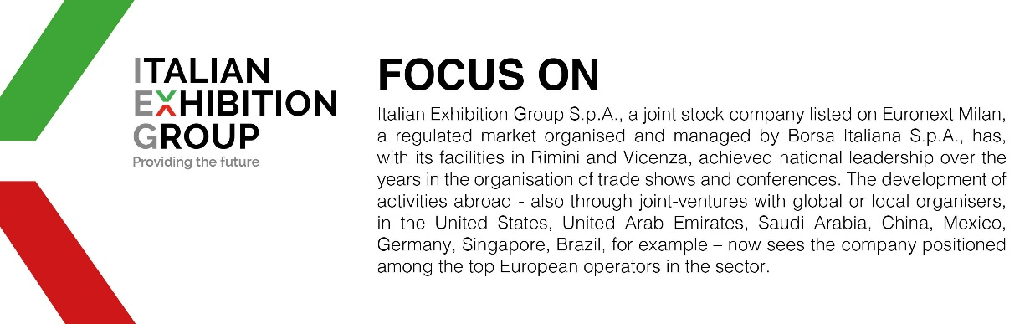

This press release contains forecast elements and estimates that reflect the management´s current opinions (´forward-looking statements´), particularly regarding future management performance, realization of investments, cash flow trends and the evolution of the financial structure. For their very nature, forward-looking statements have a component of risk and uncertainty, as they depend on the occurrence of future events. The effective results may differ (even significantly) from those announced, due to numerous factors, including, only by way of example: food service market and tourist flow trends in Italy, gold and jewellery market trends, green economy market trends; the evolution of raw material prices; general macroeconomic conditions; geopolitical factors and evolutions in the legislative framework. Moreover, the information contained in this release, does not claim to be complete, and has not been verified by independent third parties. Forecasts, estimates and objectives contained herein are based on the information available to the Company as at the date of this release.

