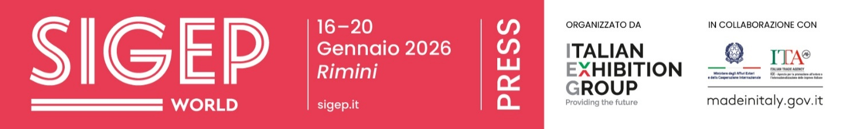

Press release no. 1
SIGEP WORLD 2026: A GLOBAL FOODSERVICE ECOSYSTEM FOR CHAINS, PREMIUM HOSPITALITY AND INNOVATIVE BARS

- From Friday 16 to Tuesday 20 January 2026, SIGEP World returns to Rimini Expo Centre, bringing together the entire foodservice ecosystem and showcasing integrated supply chains for gelato, pastry, chocolate, coffee, bakery and pizza.

- Over 1,300 exhibitors, with a 33% increase in international attendance and new exhibiting countries from Europe, Asia, the Middle East and the Americas. Top buyers from 75 countries, with India as the Guest Country.

- SIGEP Vision on global trends, the International Start-Up Village, new thematic hubs, special projects focused on hotels, supply-chain sustainability and innovative bars, as well as major international and national competitions.
sigep.it
Rimini, 22 December 2025 — From Friday 16 to Tuesday 20 January 2026, at Rimini Expo Centre, SIGEP World – The World Expo for Foodservice Excellence, curated by Italian Exhibition Group (IEG), will present the foodservice industry as a fully connected ecosystem. Gelato, pastry, chocolate, coffee, bakery and pizza will come together to engage on markets, technologies and growth strategies, offering a structured overview of the industry.
The scale of the event is reflected in the numbers: over 1,300 exhibiting brands, combining the excellence of Made in Italy with a rapidly expanding international presence. Foreign exhibitors account for 22% of the total, marking a 33% increase compared to the previous edition.
New exhibiting countries in 2026 include Canada, Algeria, Ecuador, Estonia, Serbia, Singapore, Nepal and the Czech Republic, alongside European markets such as Germany, Spain, France and Turkey, as well as national collectives from Saudi Arabia, China and Ukraine. India, the Guest Country for 2026, will participate with an institutional delegation and 50 top buyers, while the international incoming programme will welcome 500 top buyers from 75 countries.
GLOBAL TRENDS AT THE FOREFRONT: SIGEP VISION
SIGEP Vision represents the cultural core of the event, where data, market scenarios and insights are transformed into practical tools for decision-makers. Among the confirmed highlights, the SIGEP Vision Talk will open the Vision Plaza programme with an overview of global foodservice trends, supported by data and successful case studies from Europe, the United States and India. The session “The European restaurant market: opportunities and future prospects” will offer an up-to-date analysis of trends and growth opportunities in the European out-of-home industry.

AWARDS SHAPING THE FUTURE OF FOODSERVICE
The Lorenzo Cagnoni Innovation Award and the Start-Up Award return, recognising projects with high technological content applied to out-of-home supply chains. A key feature is the International Start-Up Village, now established as a global scouting hub for start-ups, investors and foodservice companies. Developed in collaboration with Italian Trade Agency and ANGI – National Association of Young Innovators, it will host 20 selected start-ups from Italy, Poland, France, Ukraine and the United States.

WHEN SUPPLY CHAINS CONVERGE
SIGEP World 2026 places strong emphasis on dialogue between supply chains. Gelato increasingly targets chain formats, pizza is evolving into an industrial and scalable model, bakeries and patisseries are experimenting with new ingredients and processes, while coffee sits at the crossroads of sustainability, technology and professional expertise. This approach moves beyond individual sectors to offer a comprehensive view of the out-of-home market. New thematic hubs further expand the scope of the exhibition. The Kitchen Equipment Hub focuses on technologies for professional kitchens and laboratories; the Frozen Product Hub highlights a fast-growing segment central to organised chains; and the Digital District brings together solutions for payments, data management, automation and customer experience – all now crucial aspects of the out-of-home industry.

SPECIAL PROJECTS
With Luxury Hotel Food Experience, food becomes a strategic driver of premium hospitality, supporting positioning, value creation and pricing. The Sustainability District connects origins and markets, featuring 21 cooperatives from cocoa- and coffee-producing countries, alongside international institutions and associations discussing sustainability, quality and trade.
Innovation Bar explores the future of bars, addressing the impact of super-automatic machines, artificial intelligence and emerging professional skills.
Gelato plays a central role in a year-round cultural and industrial development journey, with SIGEP World as its most visible expression. Through initiatives such as Gelato Meets Chains and the “What is Gelato?” campaign, gelato is presented as a professional skill and a business lever for chains, hotels and organised foodservice, combining artisanal quality with standardised processes and global scalability.

Pizza is also given dedicated focus with Pizza (R)evolution, a contemporary interpretation of one of Italy’s most iconic products. The project examines doughs, ingredients, baking techniques, training and service models, highlighting pizza’s evolution towards structured and replicable formats suited to international markets.

MAJOR COMPETITIONS
SIGEP World 2026 hosts leading international and national foodservice competitions.
On the global stage, the Gelato World Cup, Junior Pastry World Cup and Pizza Senza Frontiere – World Pizza Champion Games will bring teams and professionals from dozens of countries to Rimini.
Alongside these, national competitions — from the SCA Italy Coffee Championships to SIGEP Gelato d’Oro, as well as contests for bakers and students — reinforce the event’s educational and cultural role, promoting skills, technique and the next generation of professionals.

PRESS CONTACT ITALIAN EXHIBITION GROUP | media@iegexpo.it
head of corporate communication & media relation: Elisabetta Vitali|
press office manager: Marco Forcellini, Pier Francesco Bellini | international press office coordinator: Silvia Giorgi | press office coordinator: Luca Paganin | press office specialist: Nicoletta Evangelisti, Mirko Malgieri
MEDIA AGENCY SIGEP World: Mind The Pop
Martina Vacca: martina@mindthepop.it, mob. +39 339 748 5994; Fabrizio Raimondi: fabrizio@mindthepop.it, mob. +39 335 389 848; Benedetto Colli: benedetto@mindthepop.it, mob. 380 371 2272; Stefano Chiossi: stefano@mindthepop.it, mob. + 39 388 739 4358.

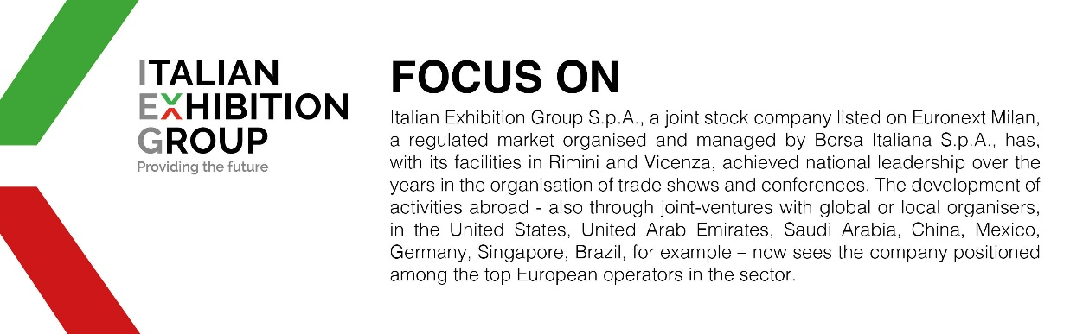

This press release contains forecast elements and estimates that reflect the management´s current opinions (´forward-looking statements´), particularly regarding future management performance, realization of investments, cash flow trends and the evolution of the financial structure. For their very nature, forward-looking statements have a component of risk and uncertainty, as they depend on the occurrence of future events. The effective results may differ (even significantly) from those announced, due to numerous factors, including, only by way of example: food service market and tourist flow trends in Italy, gold and jewellery market trends, green economy market trends; the evolution of raw material prices; general macroeconomic conditions; geopolitical factors and evolutions in the legislative framework. Moreover, the information contained in this release, does not claim to be complete, and has not been verified by independent third parties. Forecasts, estimates and objectives contained herein are based on the information available to the Company as at the date of this release.

